**Jenkins**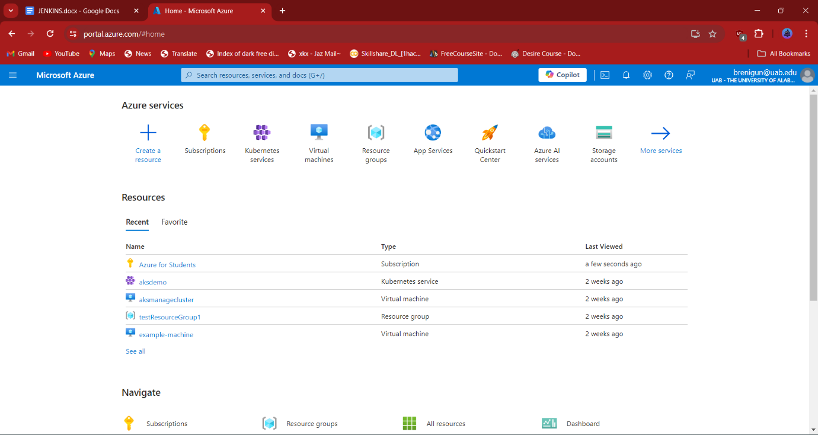

* First login to portal.azure.com, here we can see dashboard where all cloud services are available
* 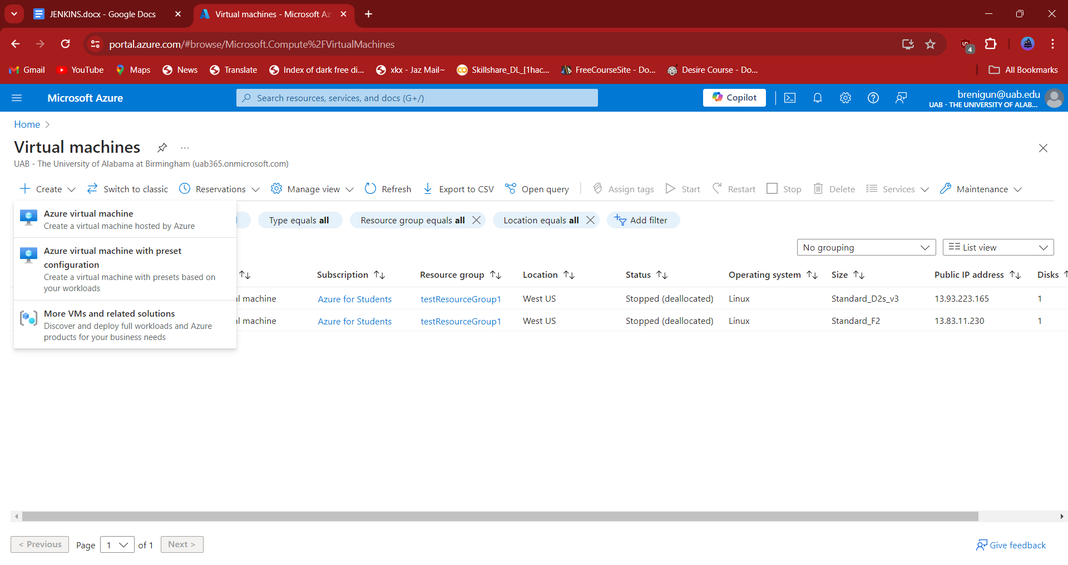Select Virtual Machines

To create Virtual Machine click on create option we get three options they are:

1. Azure virtual Machines
2. Azure virtual machine with present configuration
3. More VMs and related solutions

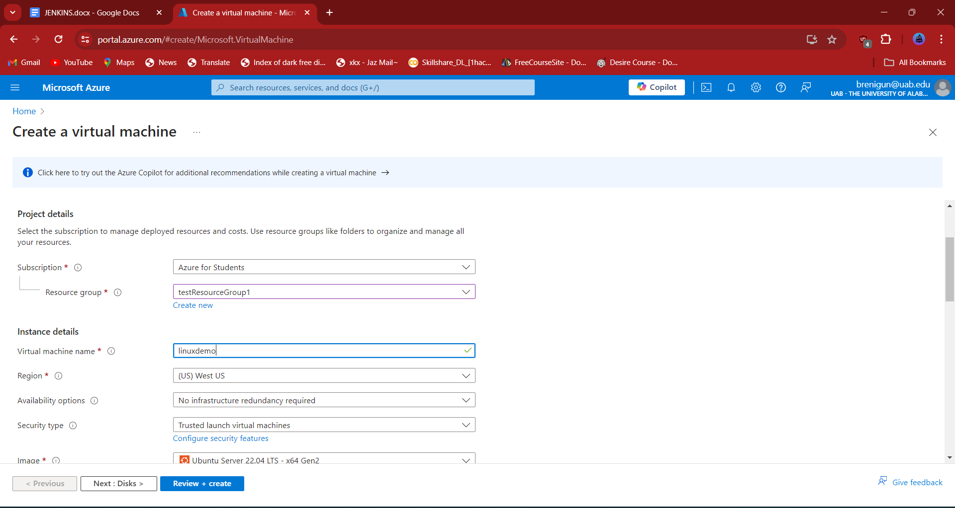 Select first option to create vm

* 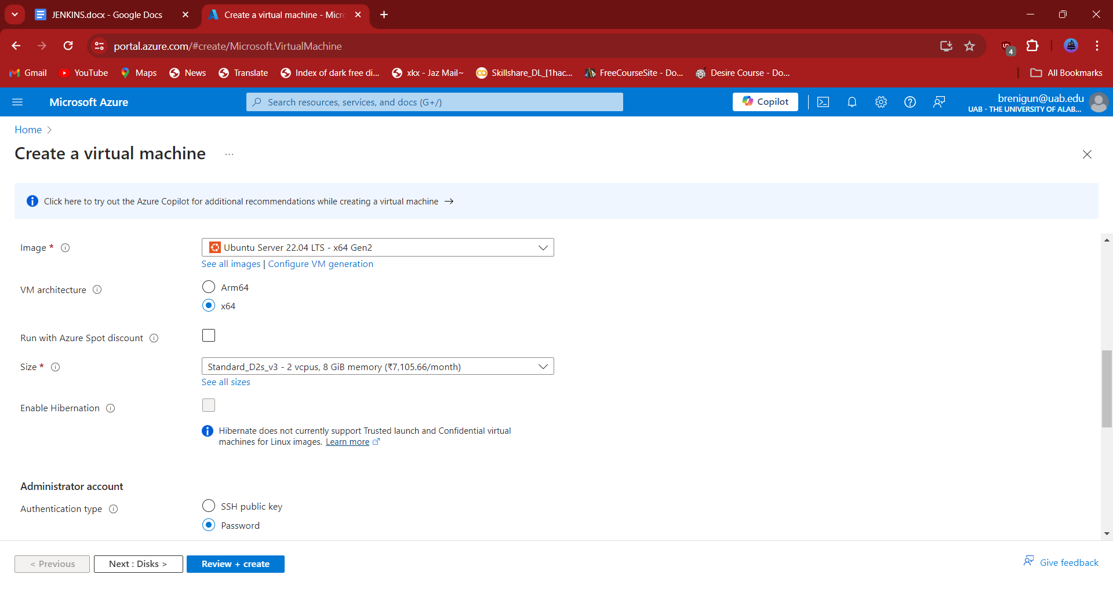Fill the details of Subscription ,Resource group, Virtual machine name, Region, Image as shown in the above figure.
* Select size of VM and Authentication type as password and fill the username and password of VM.
* 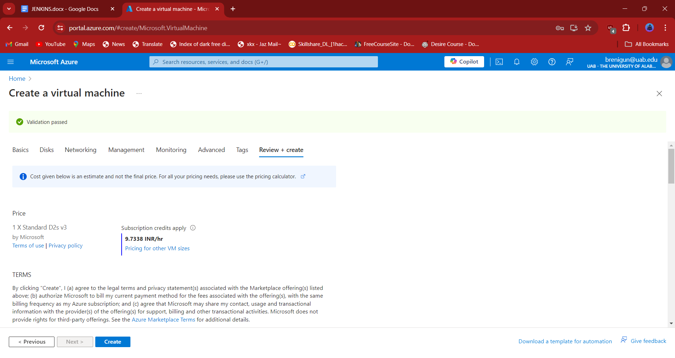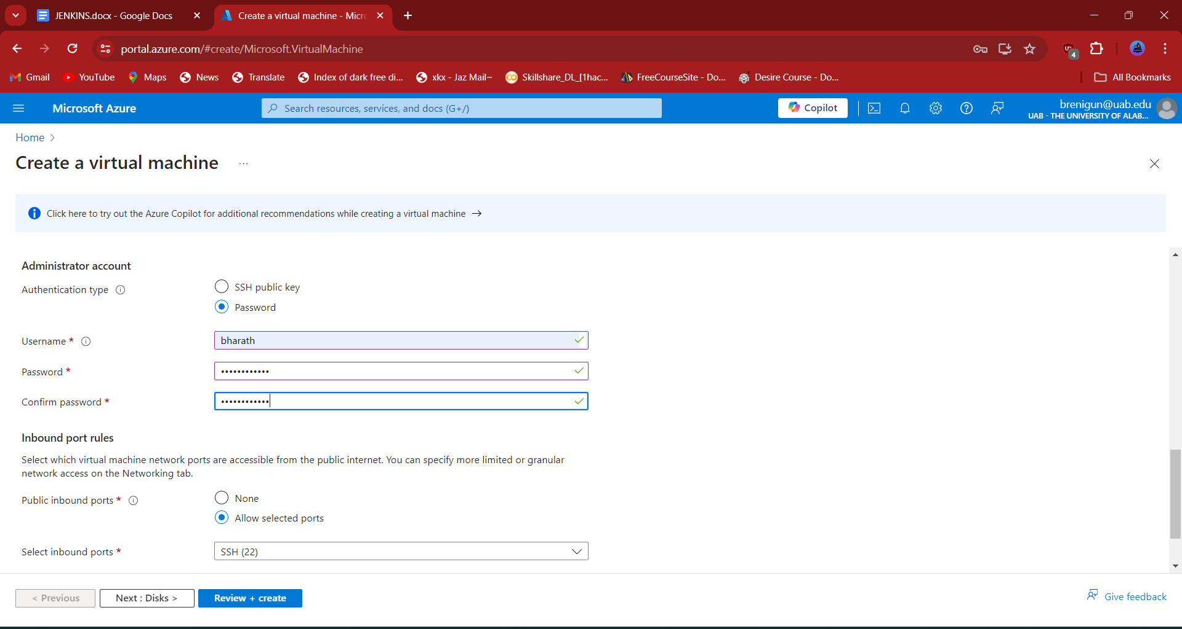Click on review+create and it will valid the details of vm with their current vm’s in data center to avoid confusion every vm in data center should be a unique name to access easily
* 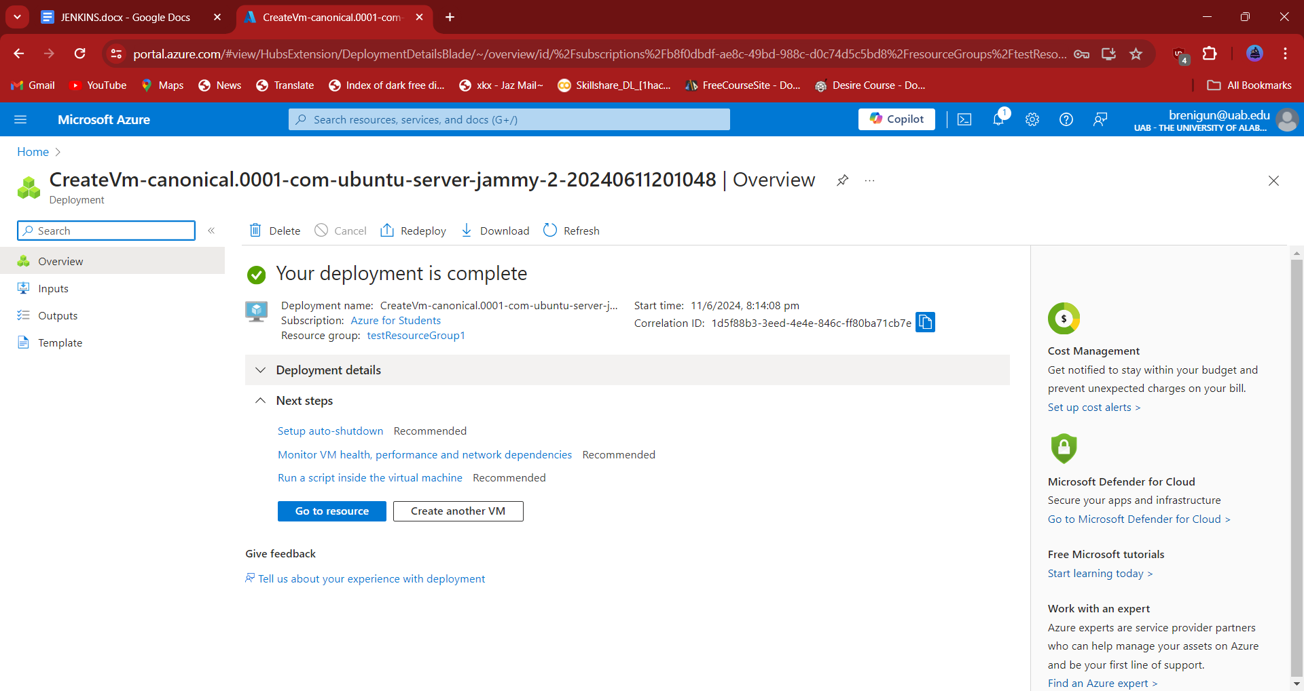Click on create option
* 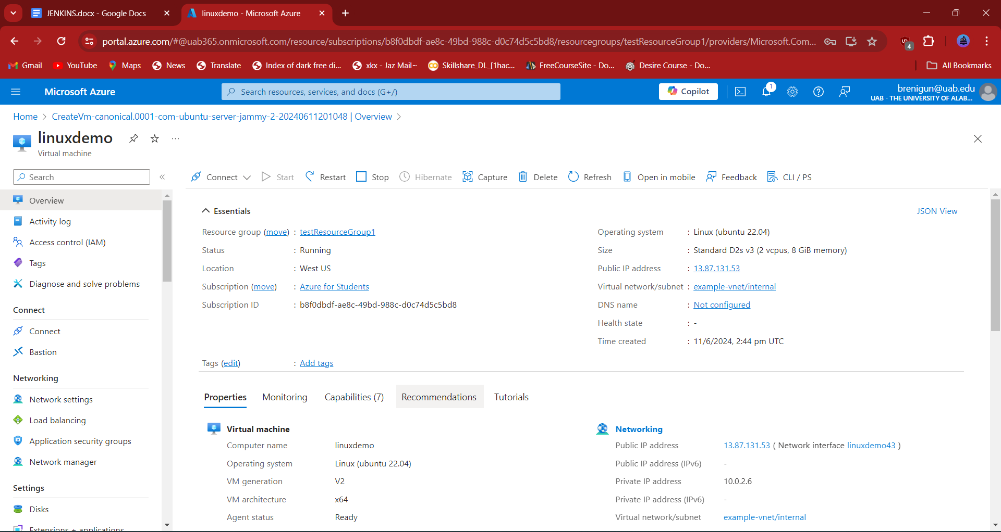Select connect to view the ip address

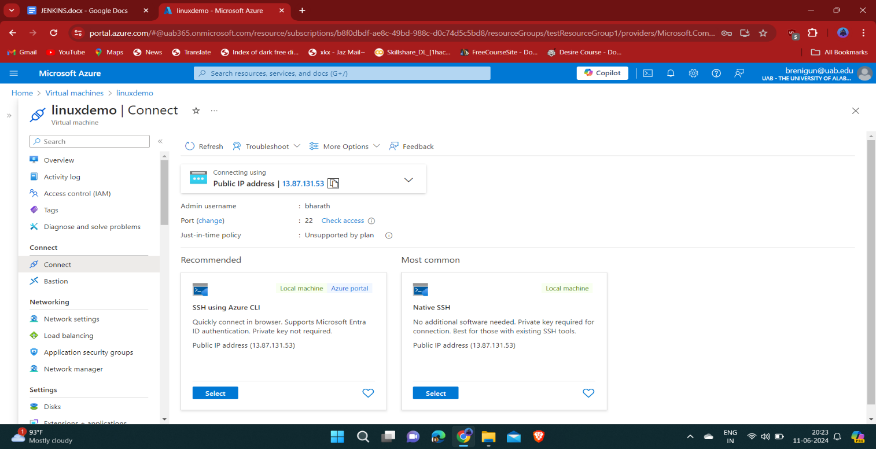

* 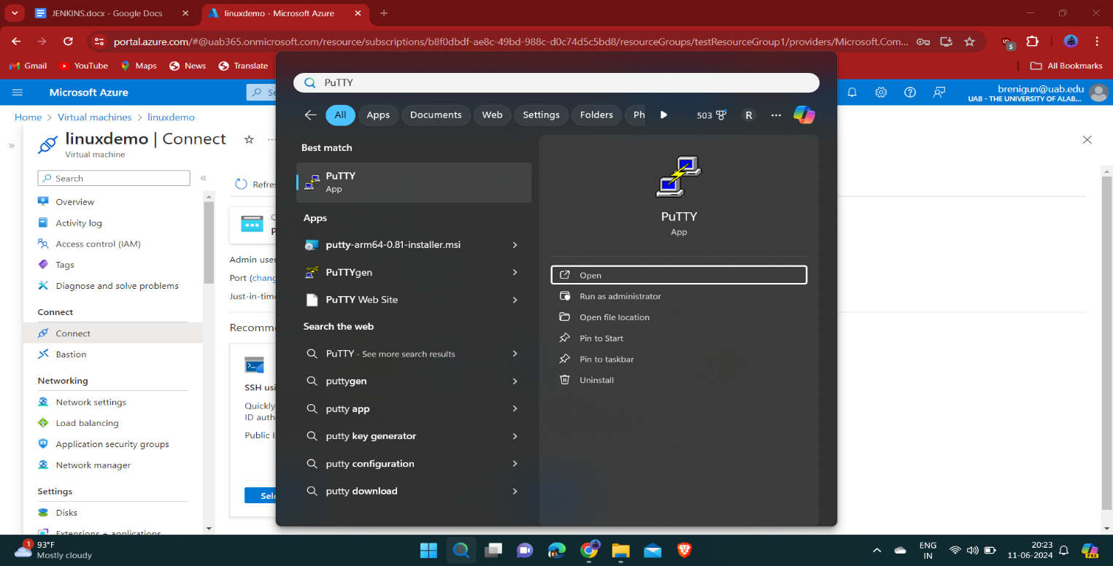Copy the ip address
* open the putty software
* 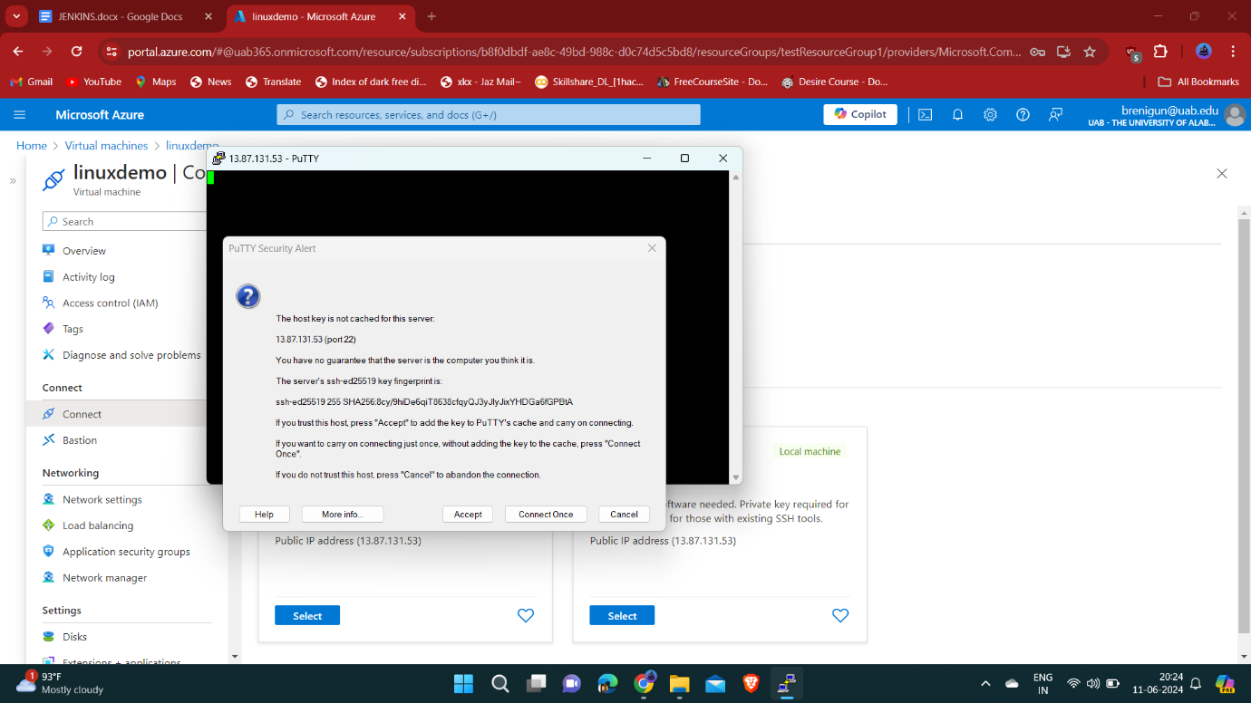paste ip address as Host Name 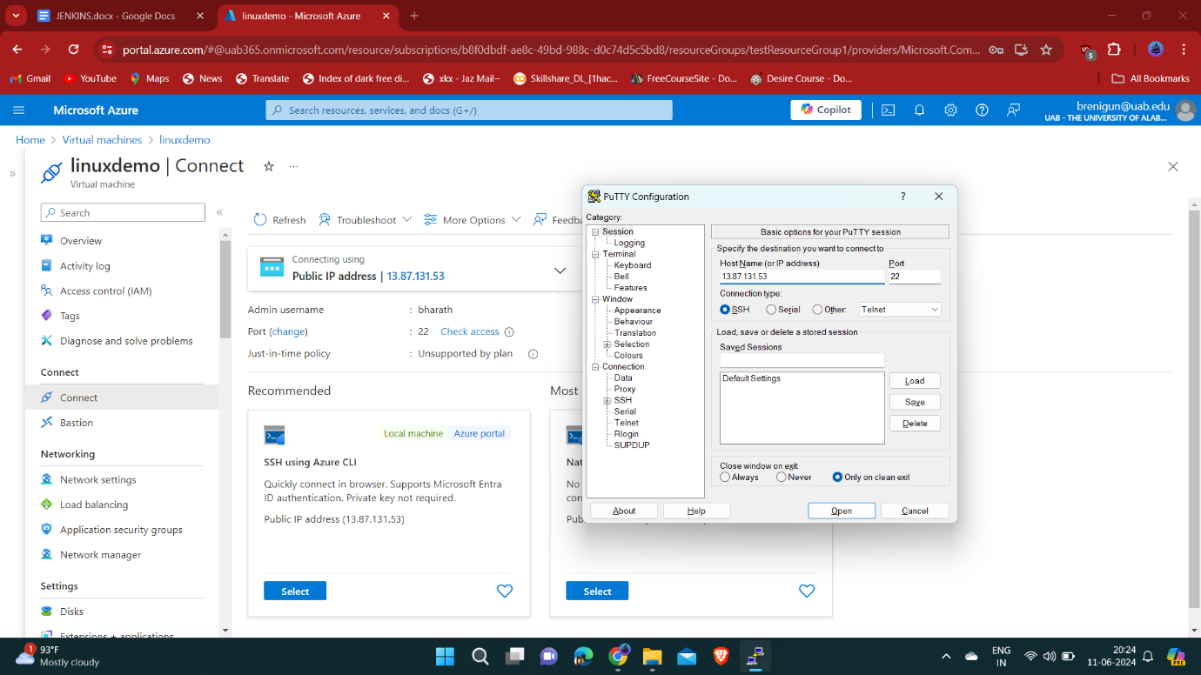
* Click on ConnectOnce

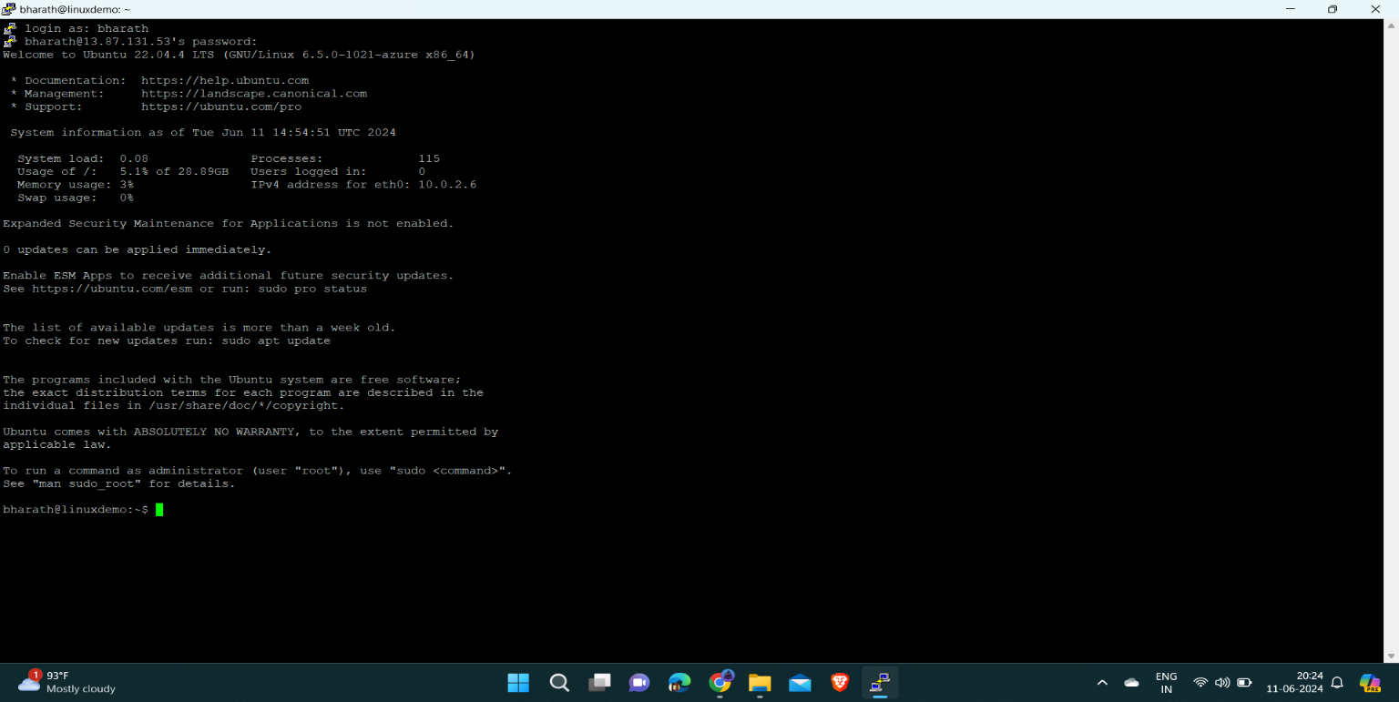

* 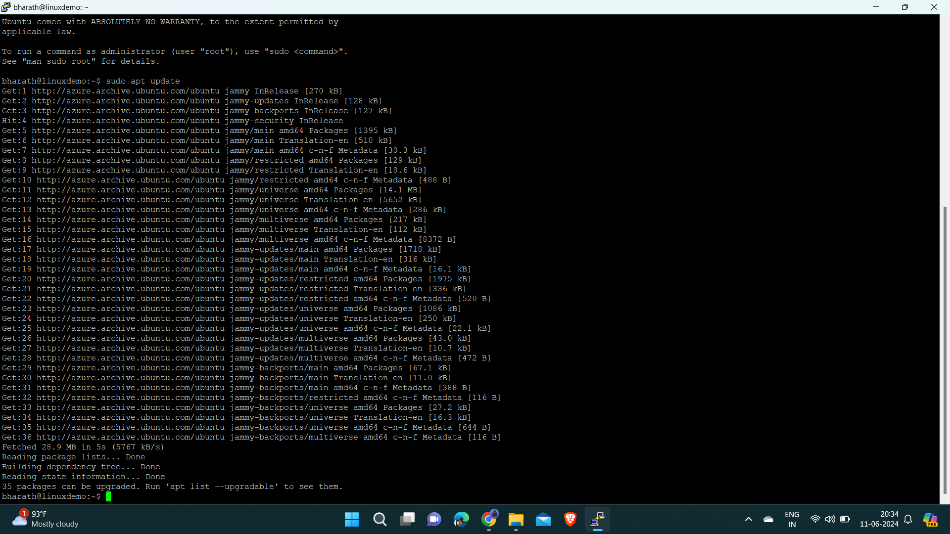sudo apt update is command to update the ubuntu linux.

To install java JDK and JRE :

* apt install openjdk-17-jdk openjdk-17-jre

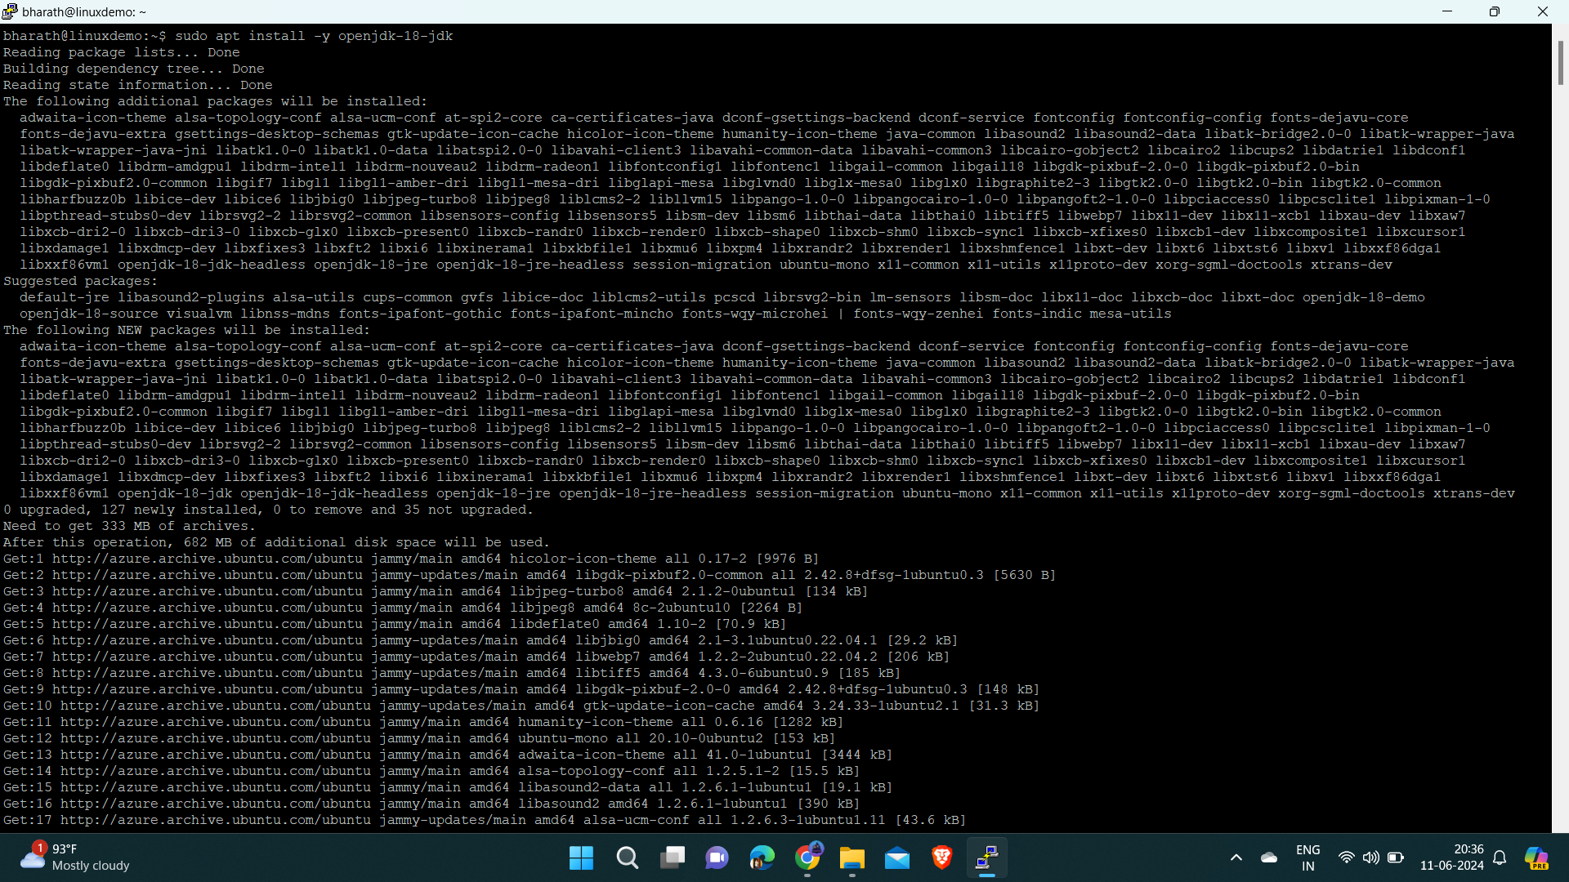

Once installed, verify the Java version using the following command:

* 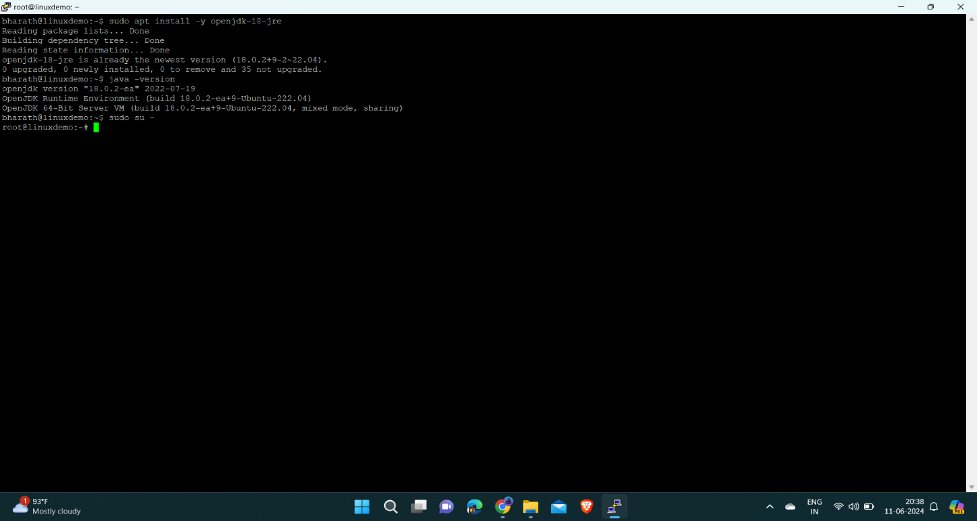java --version

Add the Jenkins Debian repository.

Import the GPG keys of the Jenkins repository using the following wget command:

* wget -q -O - https://pkg.jenkins.io/debian/jenkins.io.key | sudo apt-key add –
* sudo sh -c 'echo deb http://pkg.jenkins.io/debian-stable binary/ > /etc/apt/sources.list.d/jenkins.list'
* sudo apt update

Error : E: Package 'jenkins' has no installation candidate

Fix: -

Site: <https://stackoverflow.com/questions/70541720/jenkins-has-no-installation-candidate-error-while-trying-to-install-jenkins-on>

Note :- install jenkins in ubuntu 20.

[https://www.digitalocean.com/community/tutorials/how-to-install-jenkins-on-ubuntu-22-04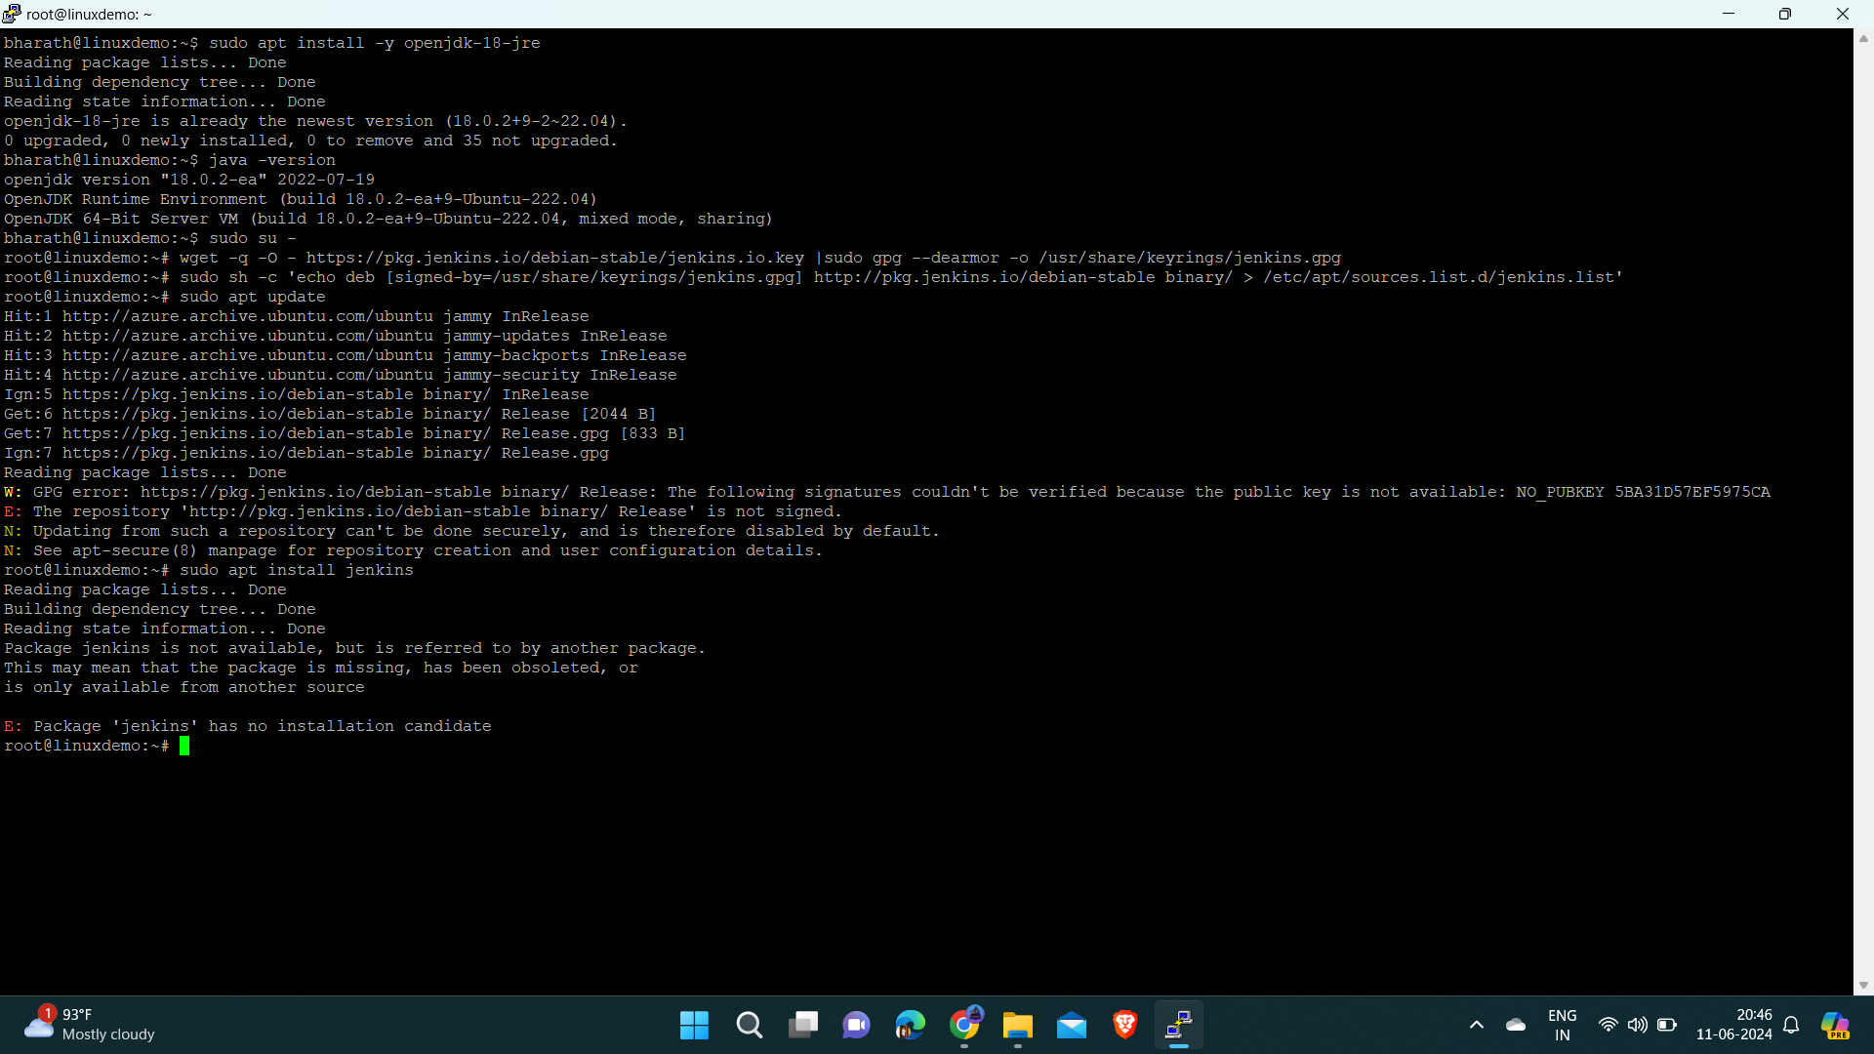](https://www.digitalocean.com/community/tutorials/how-to-install-jenkins-on-ubuntu-22-04)

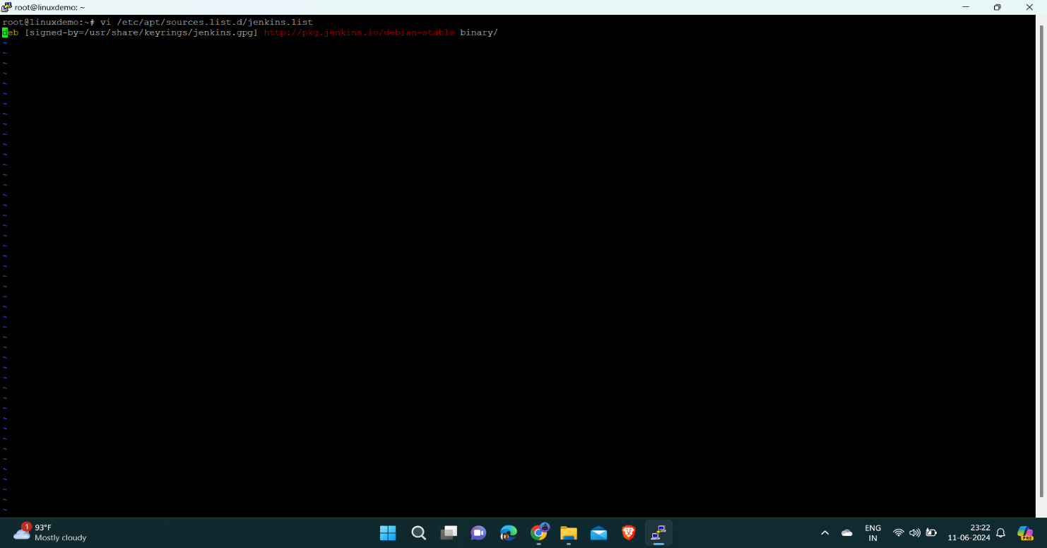

You can add [trusted=yes] in the /etc/apt/sources.list.d/jenkins.list file.

To replace text first need to get insert mode to do that press ‘i’

Initially /etc/apt/sources.list.d/jenkins.list will have,

deb [signed-by=/usr/share/keyrings/jenkins-keyring.asc] https://pkg.jenkins.io/debian binary/

Update it as,

deb [trusted=yes] [https://pkg.jenkins.io/debian binary/](https://pkg.jenkins.io/debian%20binary/)

After that run the installation instructions.

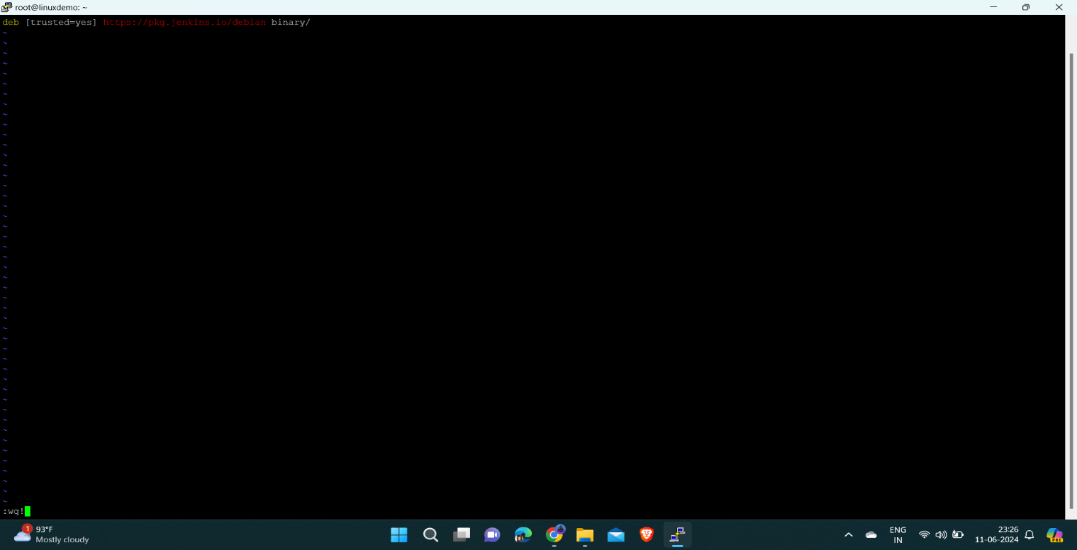

After replacing text press esc+:wq! To save successfully

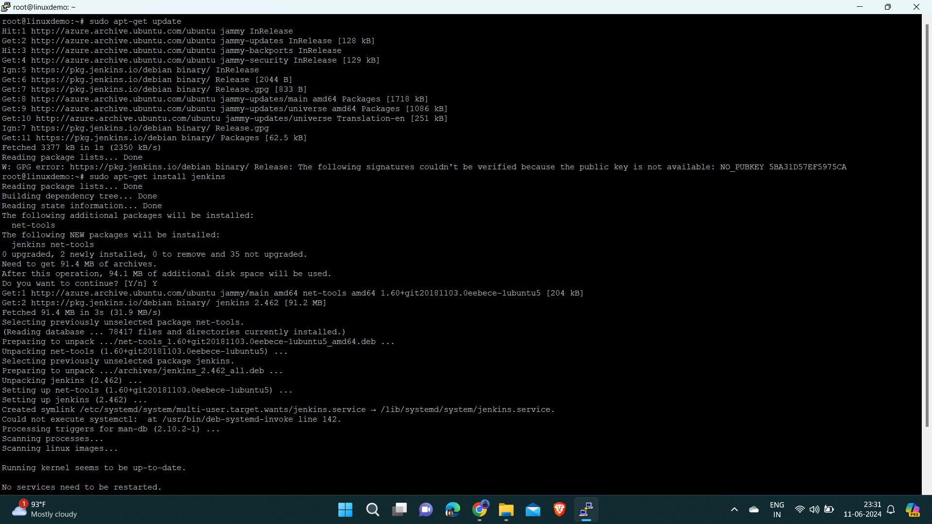

Eg: for Debian releases

sudo apt-get update

sudo apt-get install fontconfig openjdk-11-jre

sudo apt-get install Jenkins

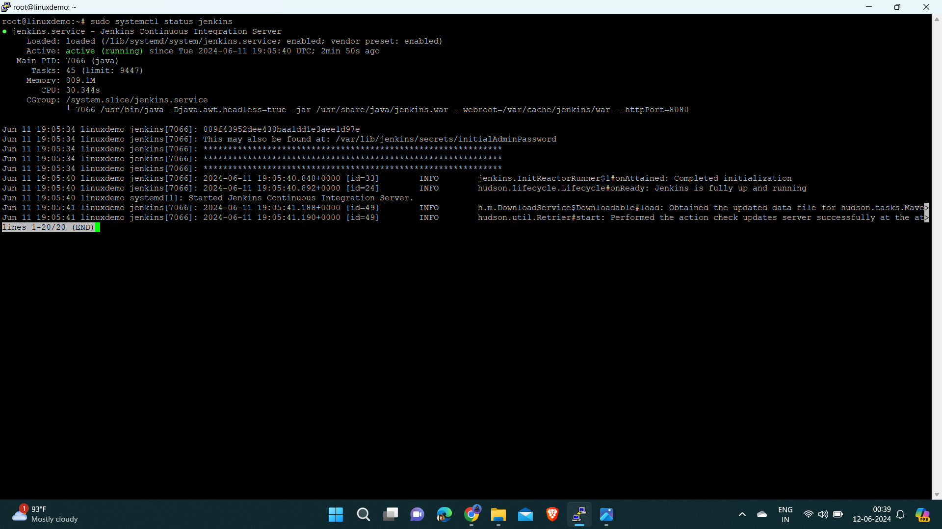

Jenkins service will automatically start after the installation process is complete. You can verify it by printing the service status:

* systemctl status Jenkins

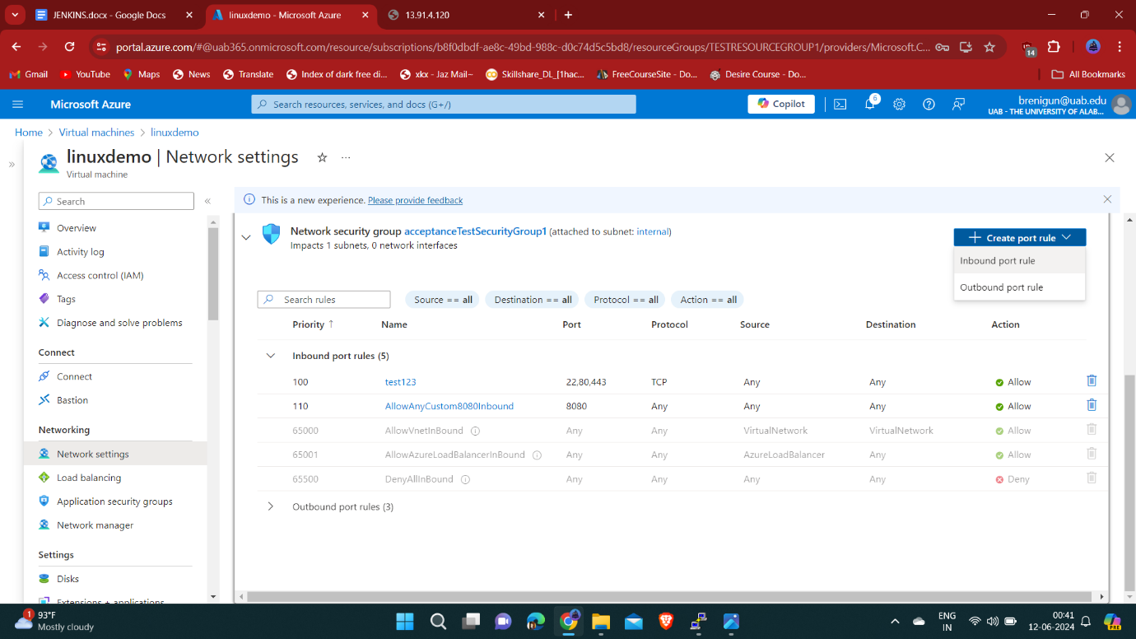we need to create Inbound port rule with highest priority to access jenkins

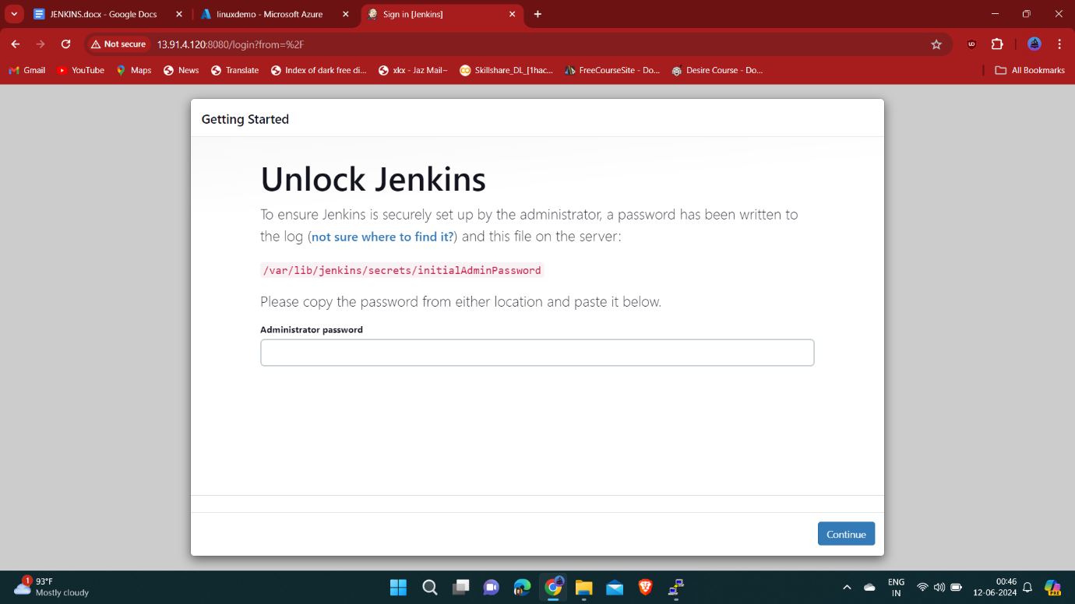

After adding Inbound port rule successfully copy the VM ip address and paste in new tab and add :8080 at end of the ip address.

We need to enter the Administrator password for the first attempt, later we need to create login account.

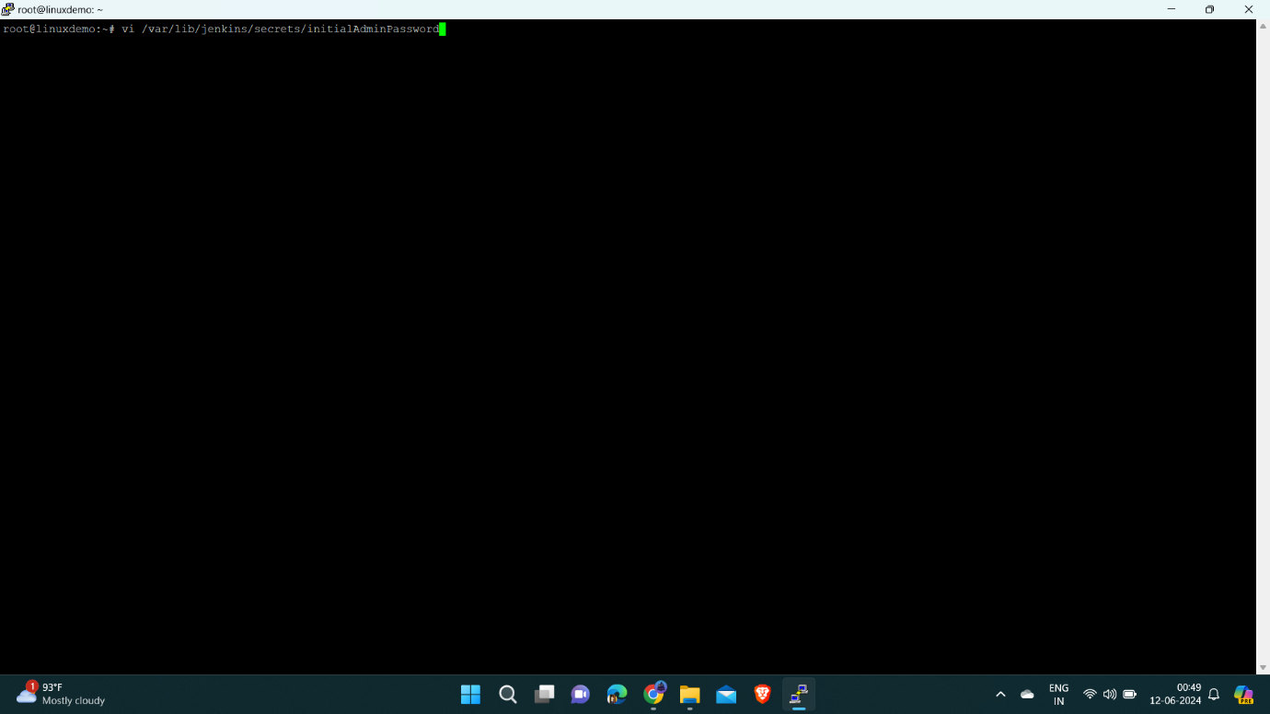To find the password of Jenkins enter this command:

* vi /var/lib/jenkins/secrets/initialAdminPassword

Copy the password from your terminal, paste it into the Administrator password field and click Continue.

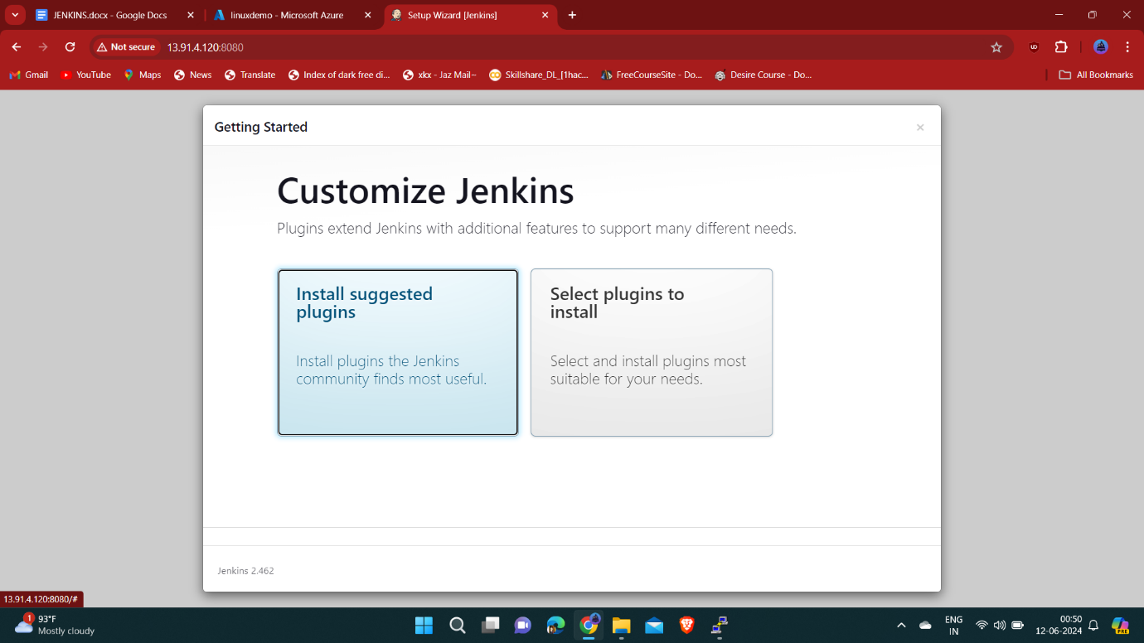

On the next screen, the setup wizard will ask you whether you want to install suggested plugins or you want to select specific plugins. Click on the Install suggested plugins box, and the installation process will start immediately.

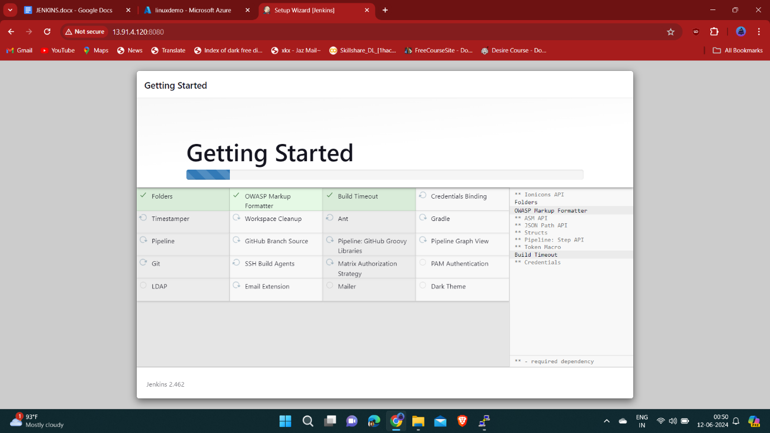

After installation

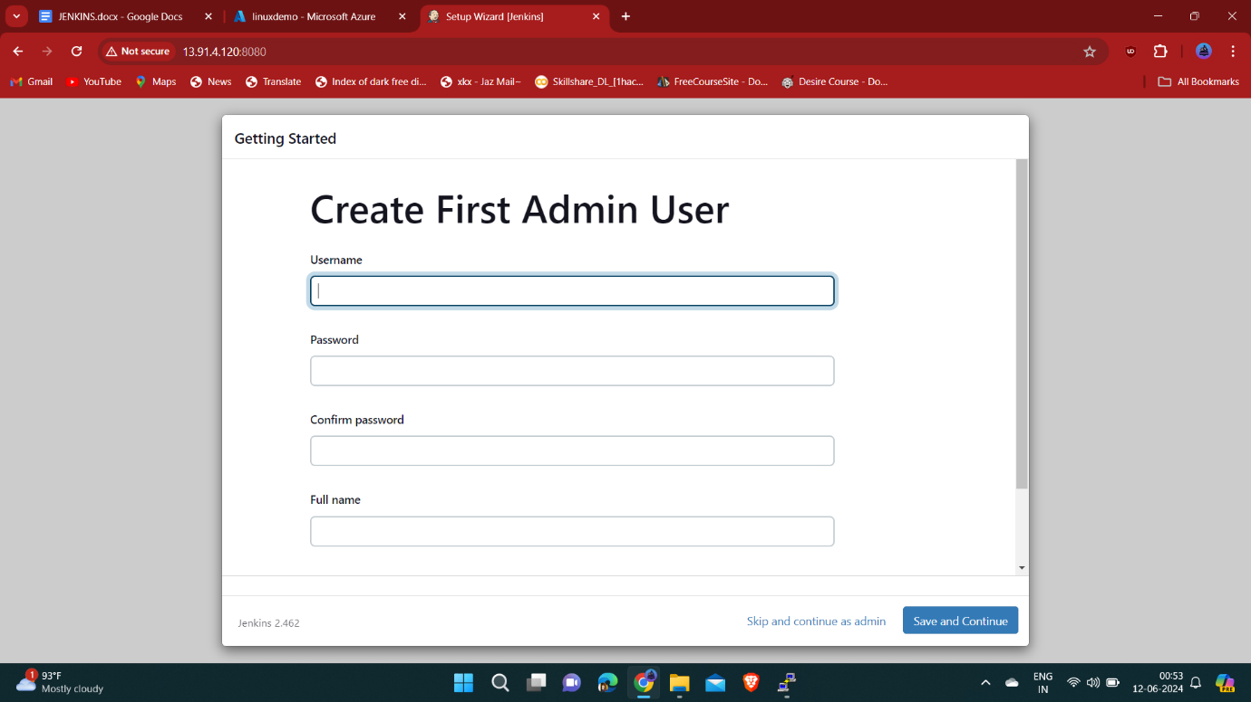

Once the plugins are installed, you will be prompted to set up the first admin user. Fill out all required information and click Save and Continue.

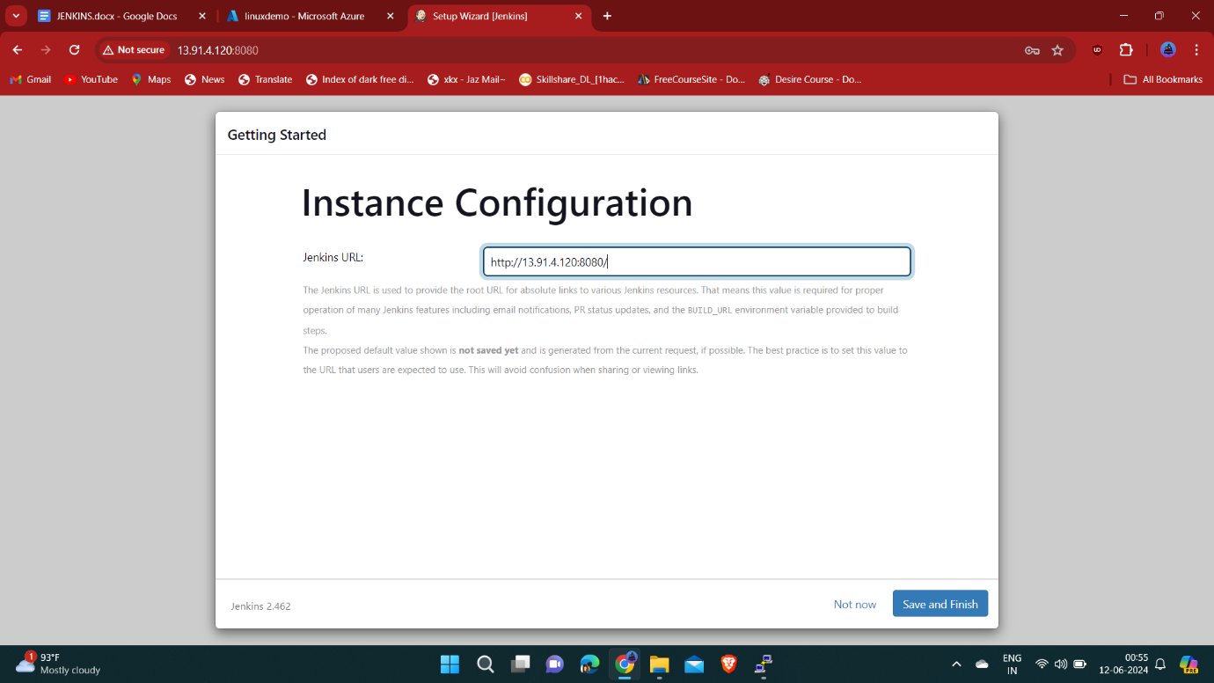

Enter the vm ip address with port number and click on Save and Finish.

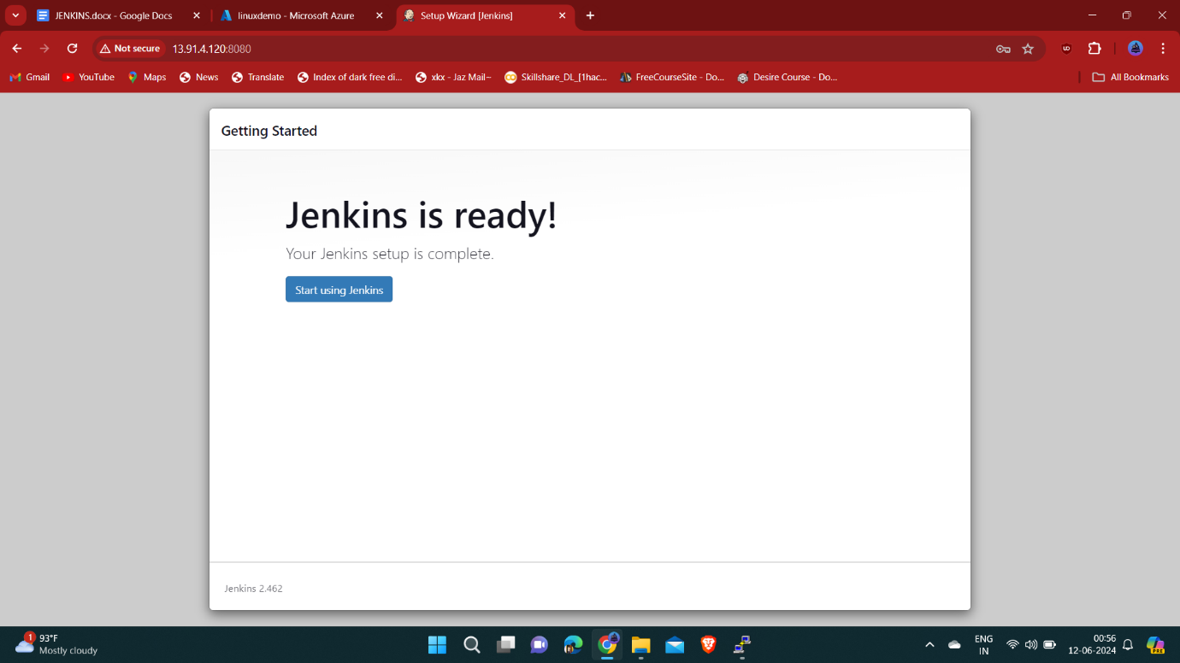

Click on the Start using Jenkins button and you will be redirected to the Jenkins dashboard.

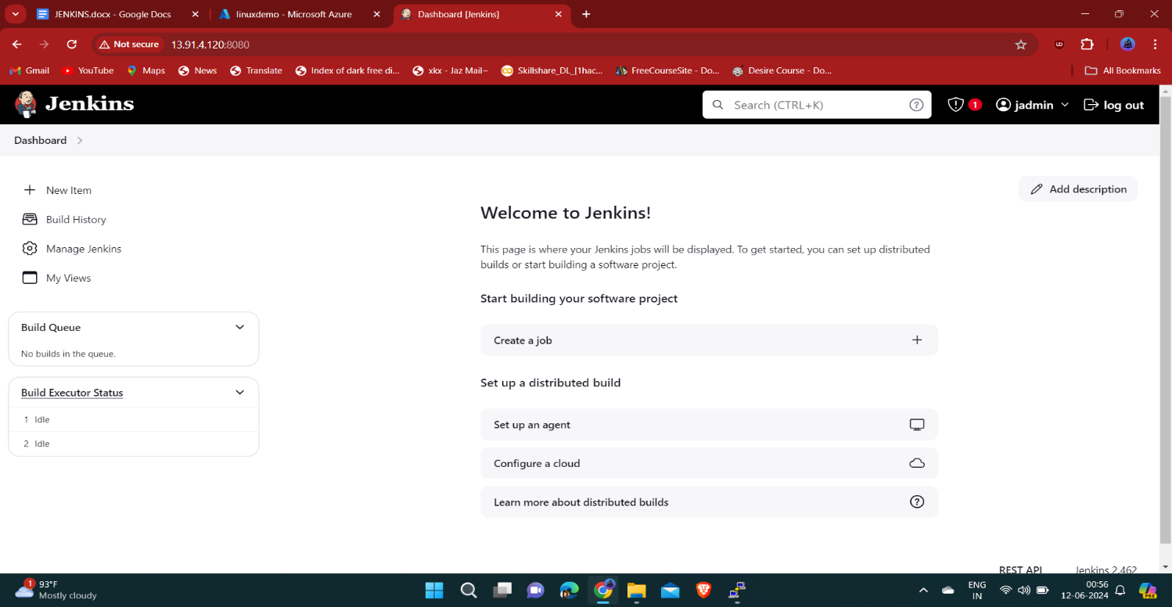

At this point, you’ve successfully installed Jenkins on your system.

Install maven software in local machine.

* sudo apt update
* sudo apt install maven
* mvn -version

After installing maven you need to add extension in Jenkins also

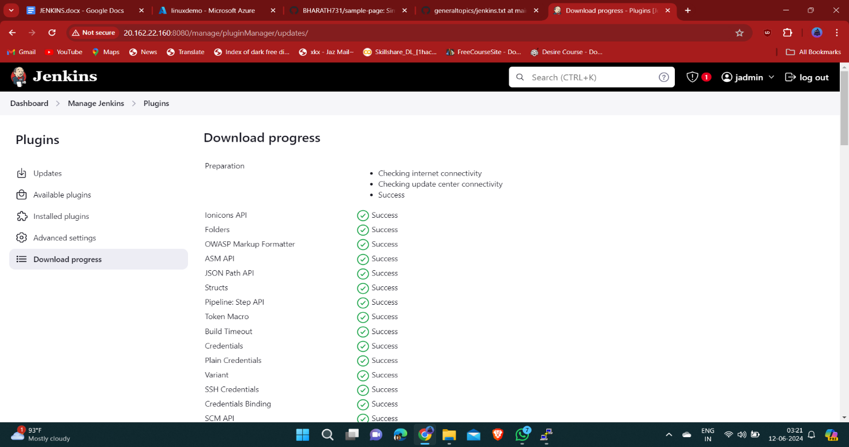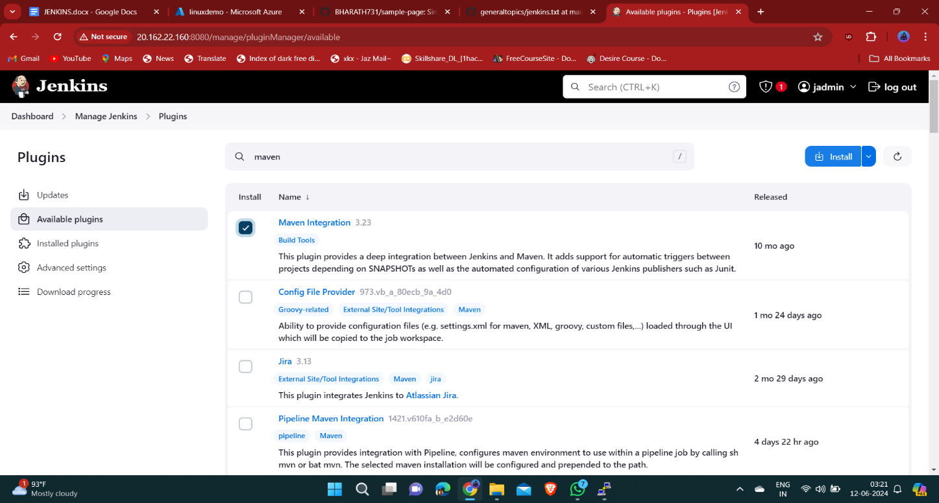In dashboard select Manage Jenkins in that go to Plugins , click on Available plugins and search for maven click on install

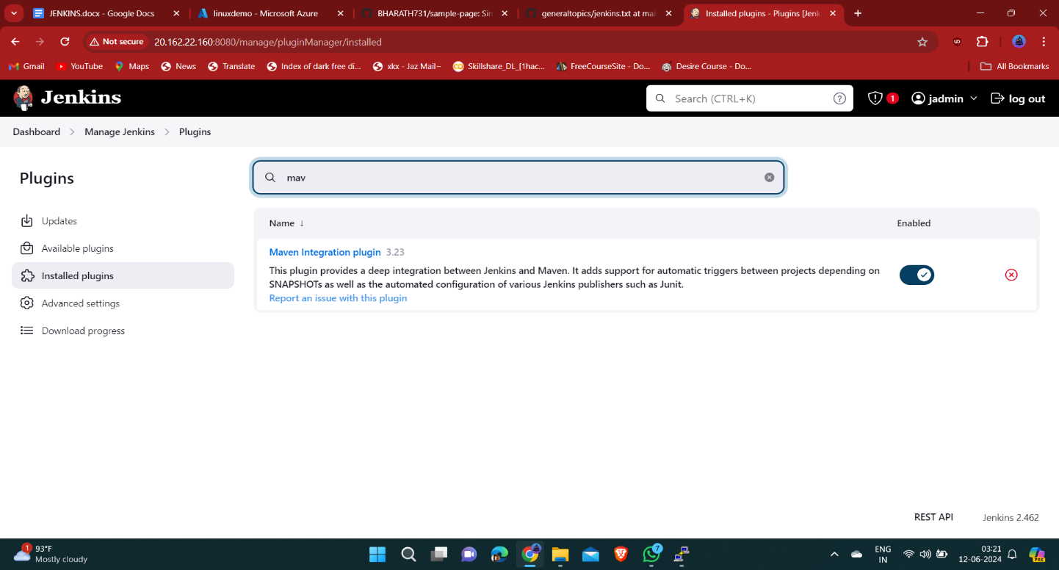After maven plugin installation verify that is available in installed plugins or not

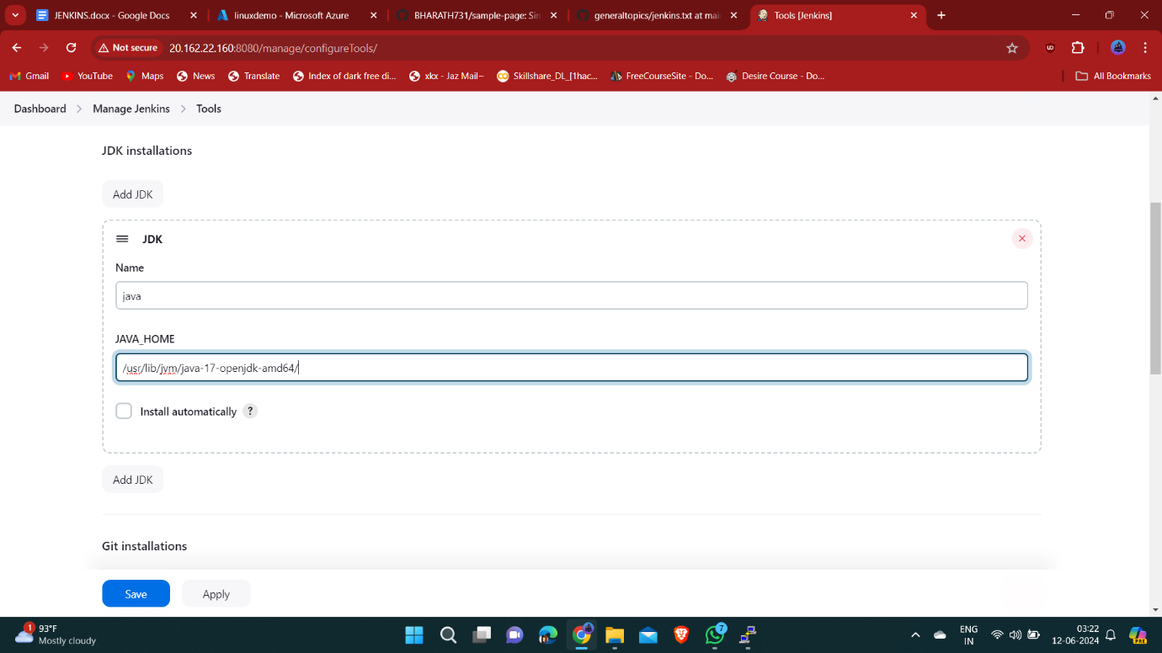

We need to add path of java and maven in tools which are located in our vm.

Click on apply and save.

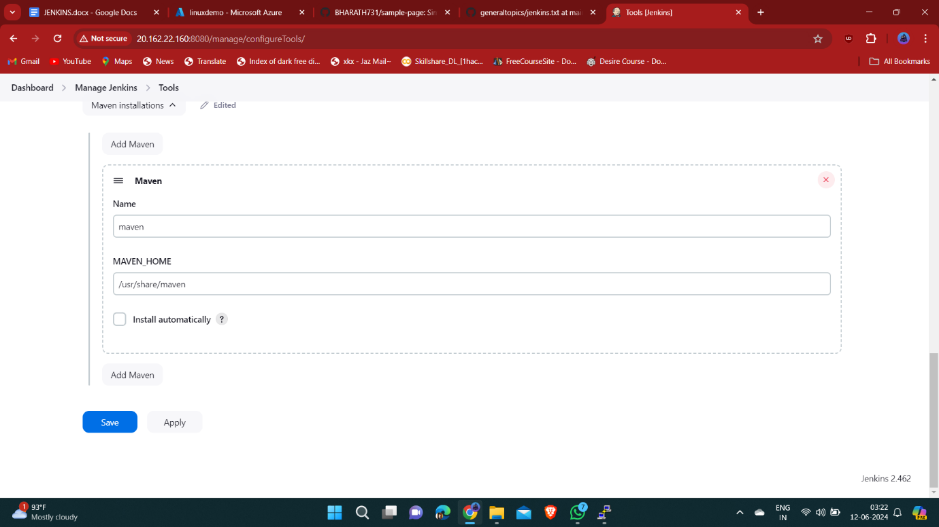Added maven path successfully.

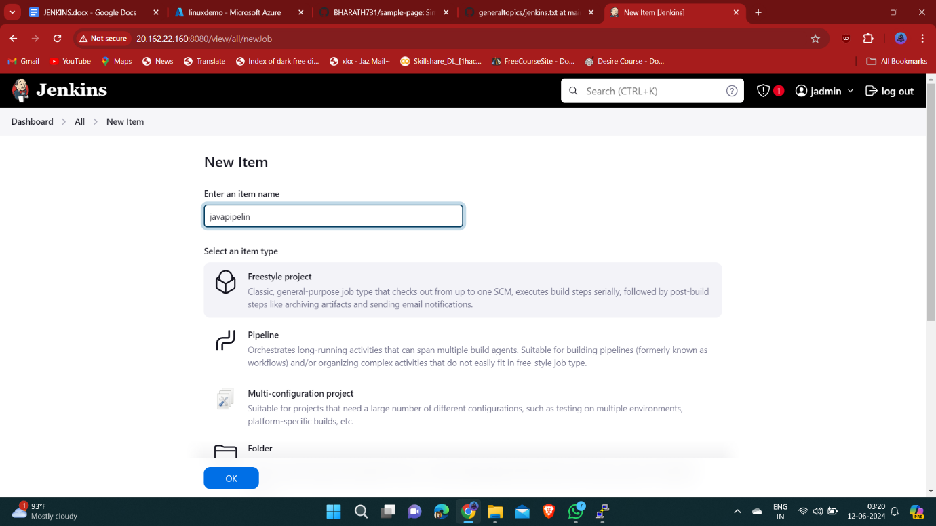Create a new pipe line name it as javapipline and select Freestyle project and click ok.

Open java github repo and copy the github repo url.

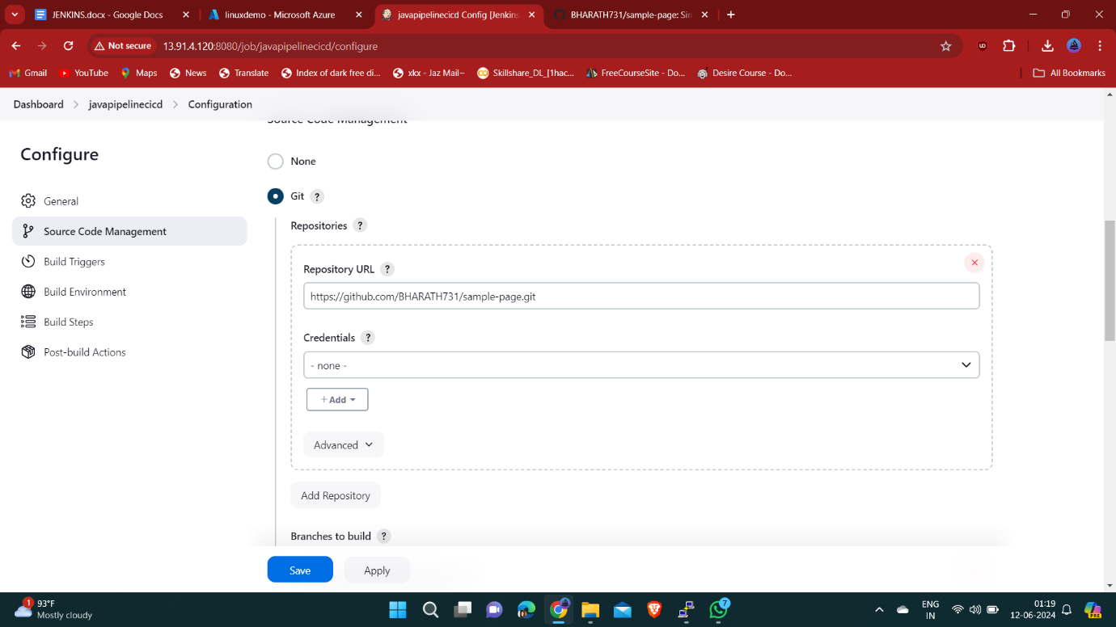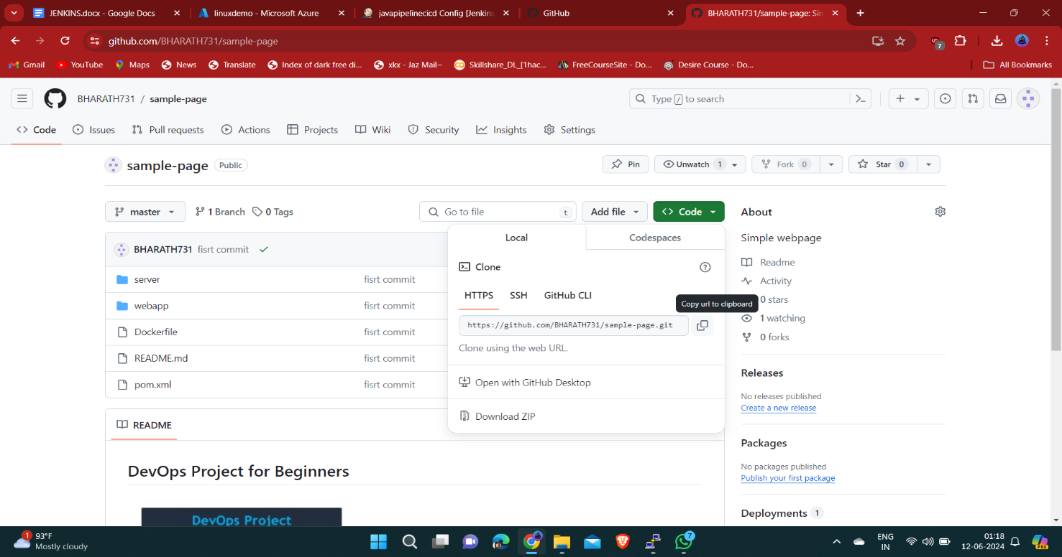

Paste the github url in Dashborad/javapipeline/Configuration

Select source code management in that choose git if the repo is public only url needed to paste otherwise if repo is private we need to enter the github repo credentials also using Advanced option.

Click on Apply and save.

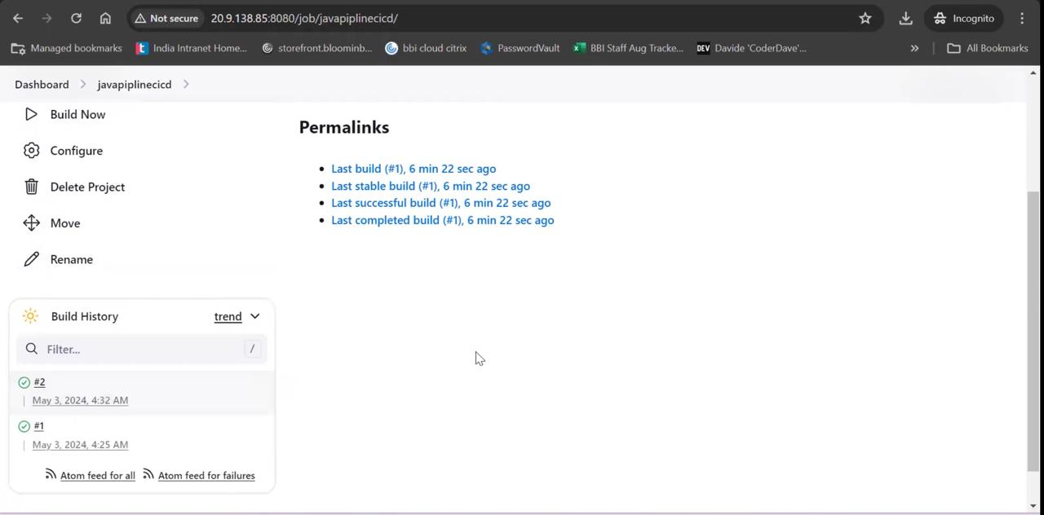

After build complete it will generate webapp.war file which is located in console output.

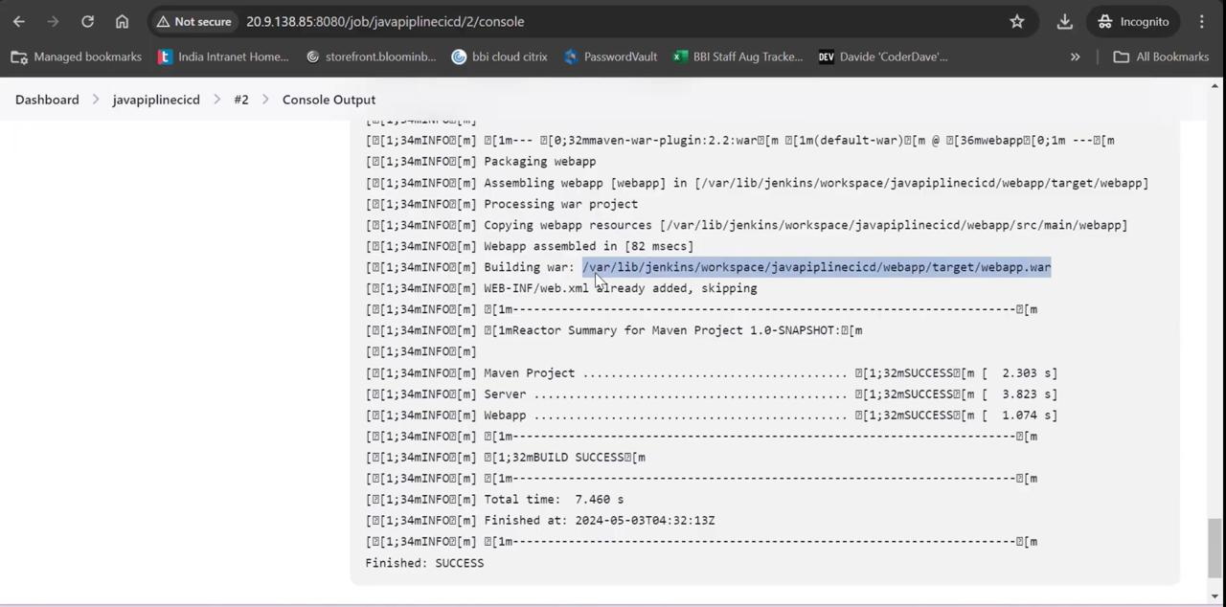

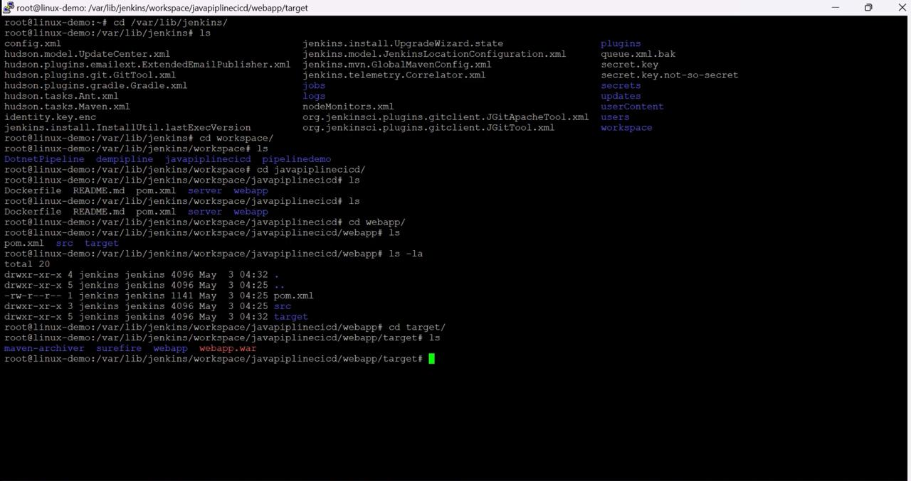Check the same webapp.war files is created in your vm also.

To check that commands are:

* sudo su –
* cd /var/lib/jenkins/workspace/javapipeline/webapp/target/
* ls

After typing ls we can see webapp.war file

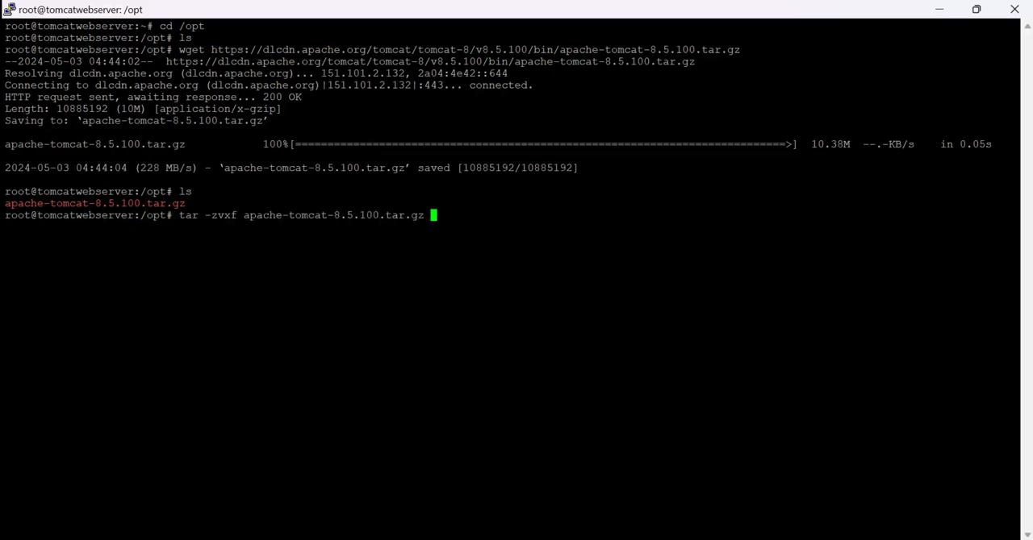

Create another vm or can do this process in same vm also . while doing on same vm make sure that to increase the size of vm and it will restart again then continue this process.

Download and install tomcat using this following commands:

* cd /opt
* wget <https://dlcdn.apache.org/tomcat/tomcat-8/v8.5.81/bin/apache-tomcat-8.5.81.tar.gz>
* tar -zvxf  /opt/apache-tomcat-8.5.81.tar.gz

It will download and install.

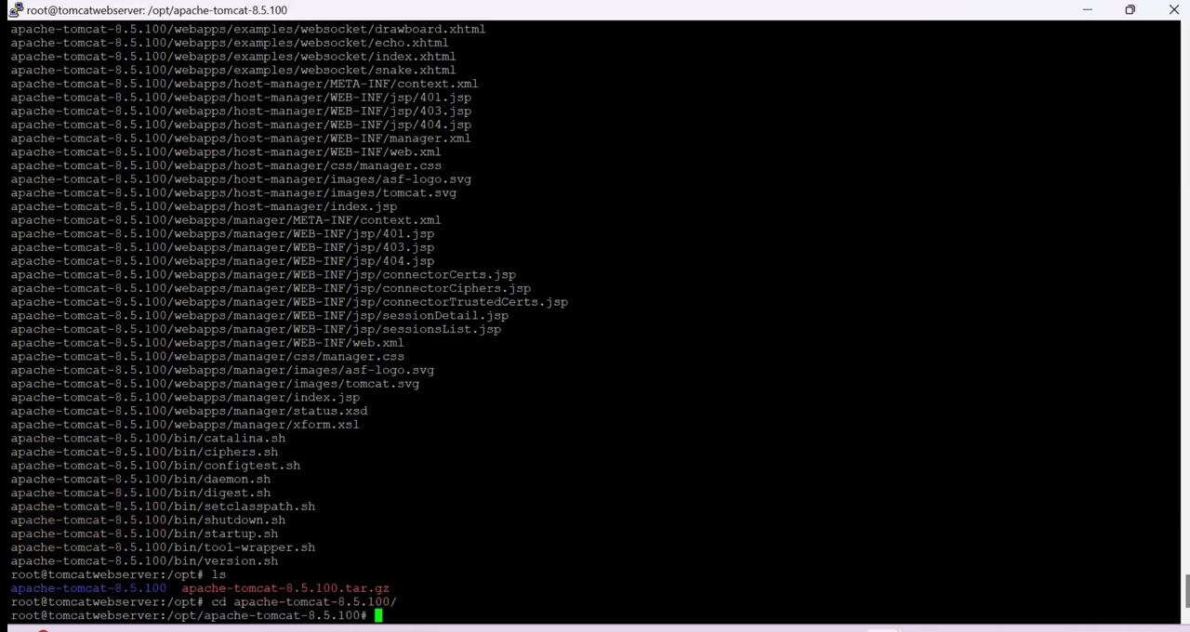If you are created another vm install java in that vm.

After installation type to following command to entire into the tomcat directory

* cd apache-tomcat-8.5.100/
* ps -ef | grep tomcat
* cd bin/
* ls -la

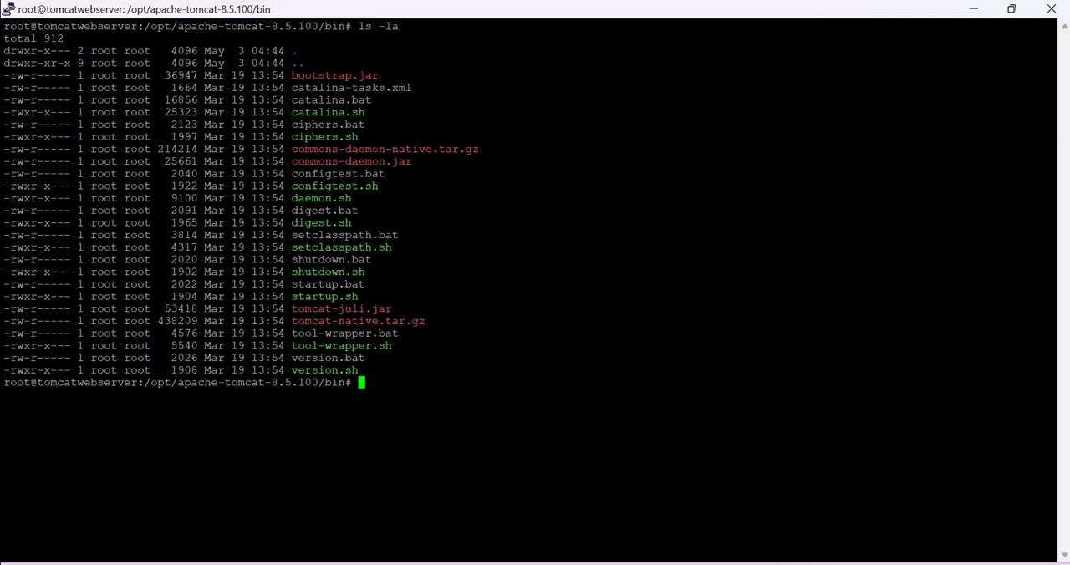

Type chmod +x ./startup.sh : To give the permission for execute or start

Again type : ls -la

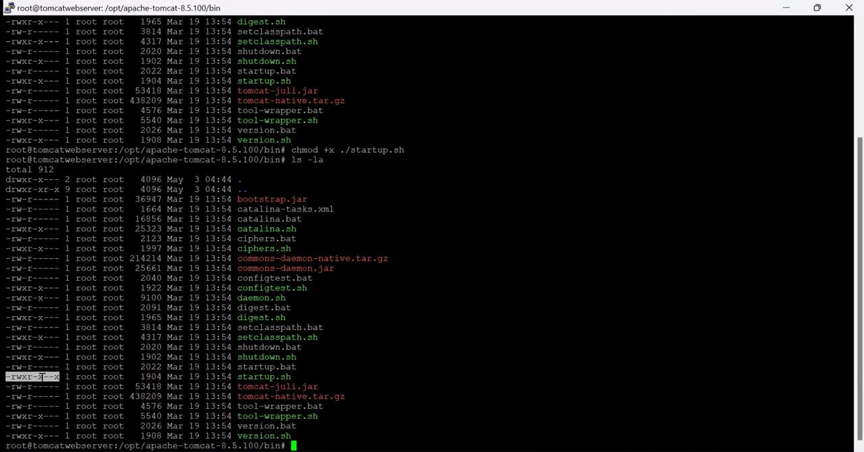

Observe the difference between the permissions when compare to above file.

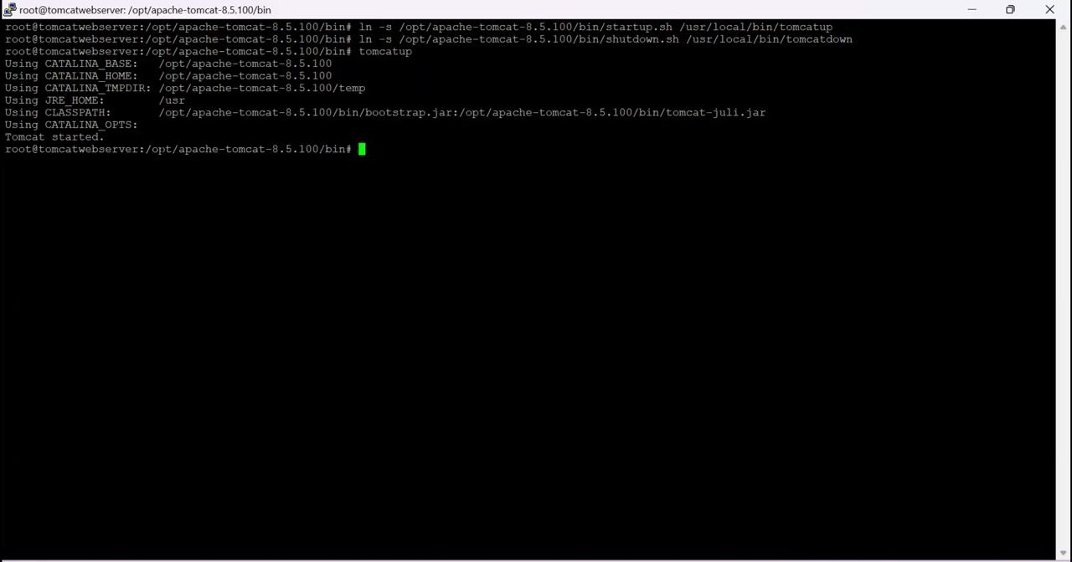

After changing the permissions we have to create to shortcut to start and stop tomcat server instead to coming to this directory .

Commands are:

* ln -s /opt/apache-tomcat-8.5.81/bin/startup.sh /usr/local/bin/tomcatup
* ln -s /opt/apache-tomcat-8.5.81/bin/shutdown.sh /usr/local/bin/tomcatdown
* tomcatup

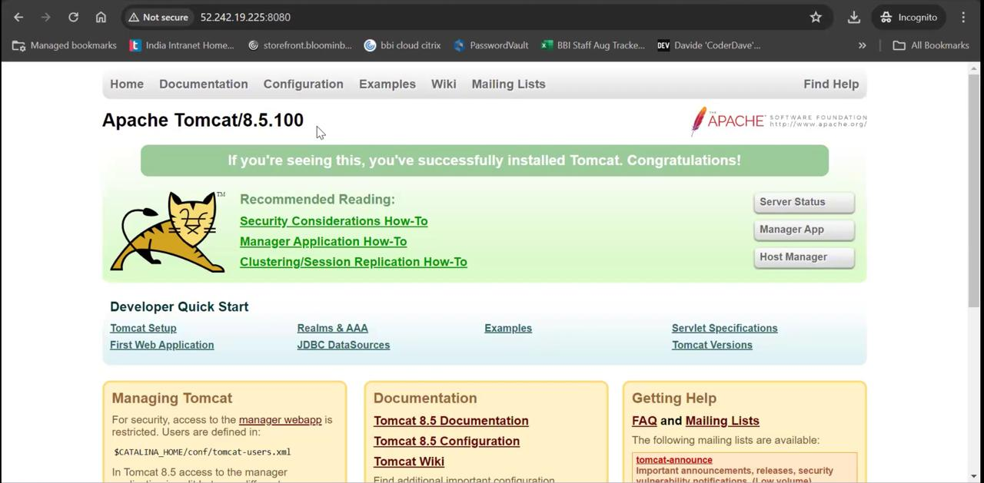

Using unique ports for each application is a best practice in an environment. But tomcat and Jenkins runs on ports number 8080. Hence lets change tomcat port number to 8090. Change port number in conf/server.xml file under tomcat home

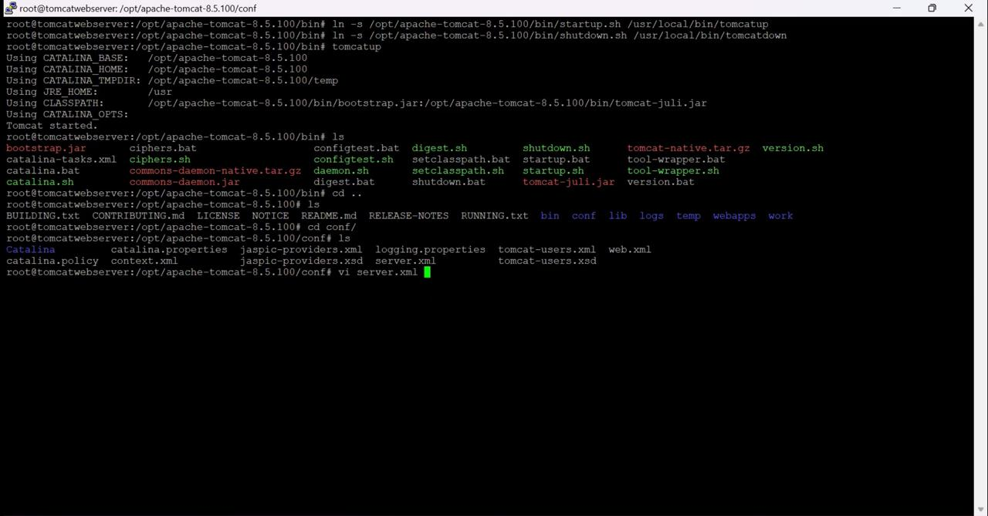

Commands are:

* ls
* cd ..
* cd conf/
* vi server.xml

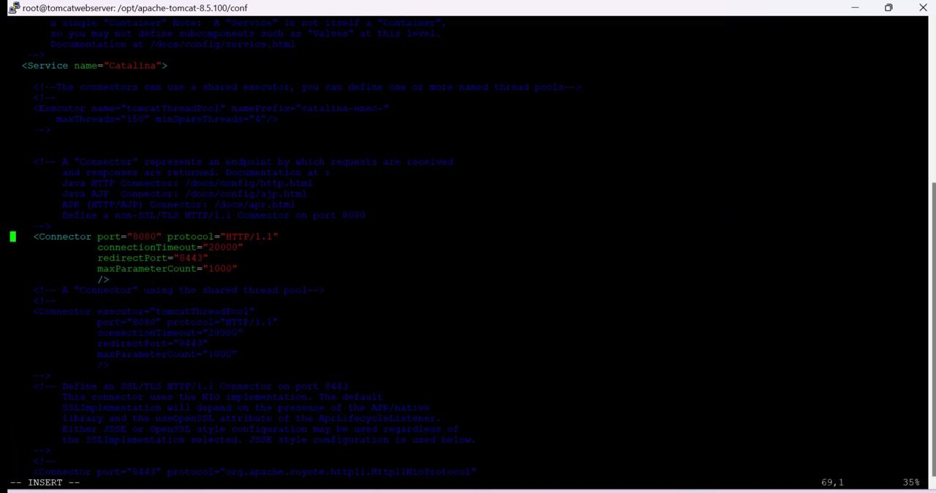

Type ‘ i ‘ enter into insert mode

Change the port number 8080 to 9000 in Connector port and press esc+:+wq! to save and exit from the file.

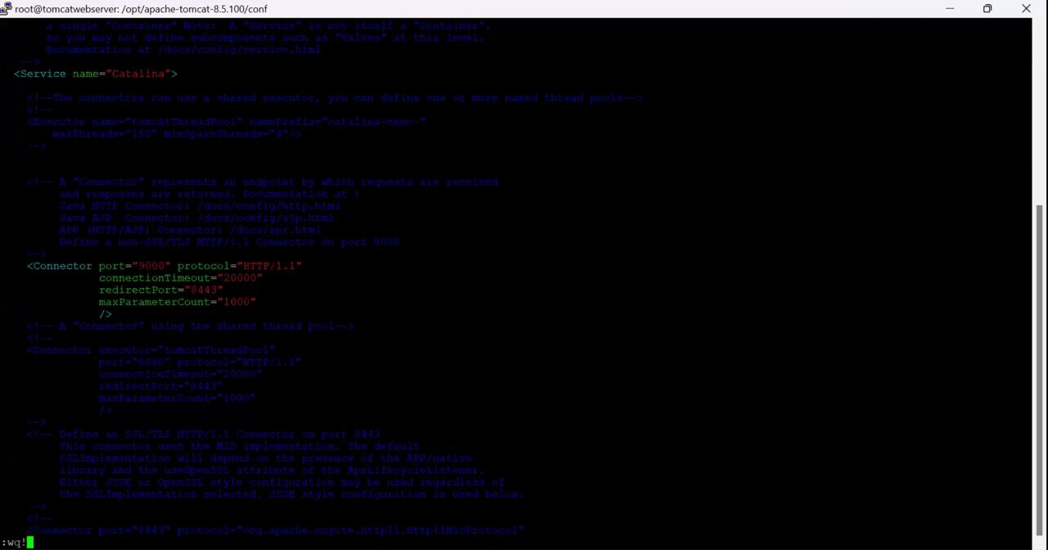we need to add inbound rule again with port number 9000

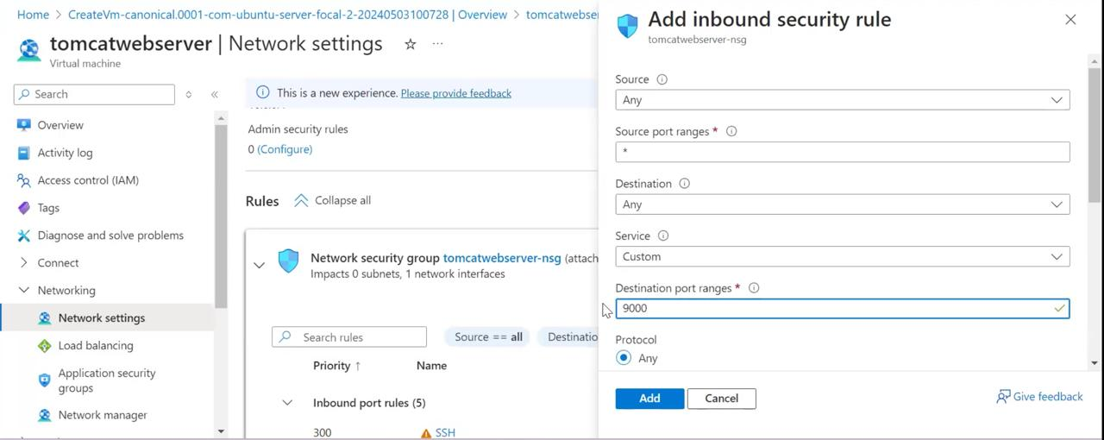click on add .

copy the ip address to vm and add port number 9000 at end to ip address

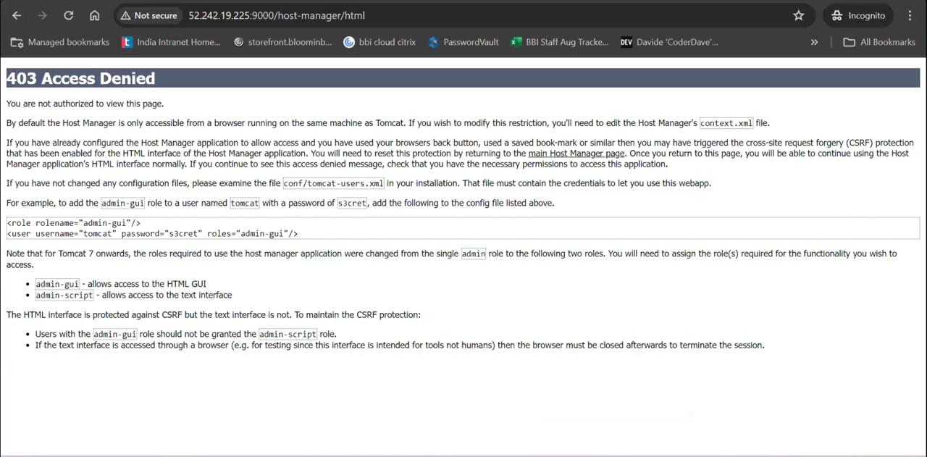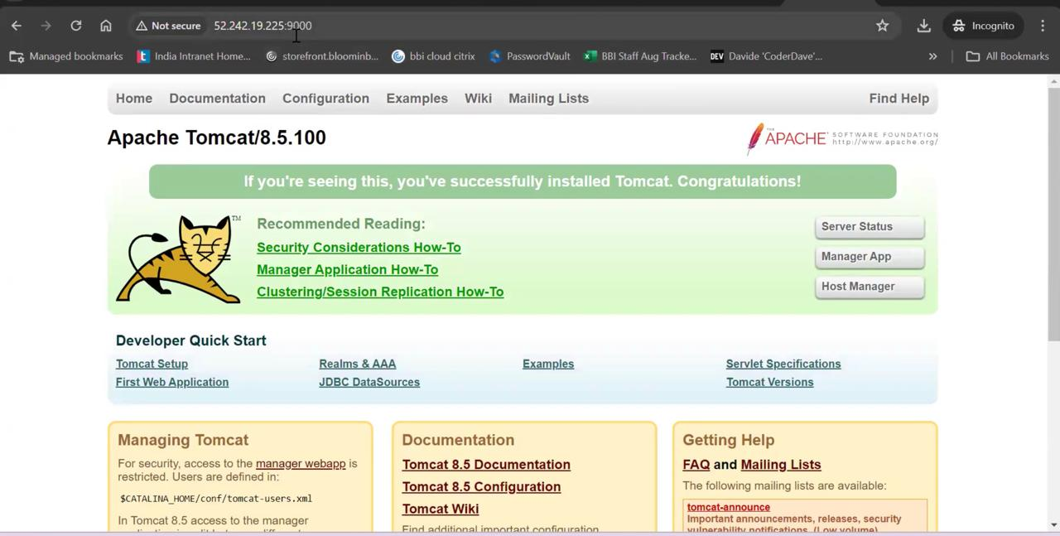Now click on the host manager.

we get Acess Denied. We need to add the roles to view the deployment.

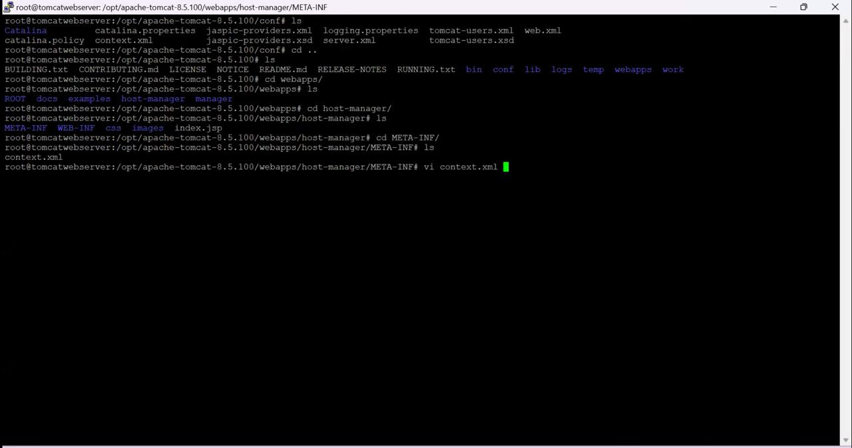

We have to enter into context.xm file to add the roles.

* cd .. -> Go to apache-tomcat-8.5.100 directory
* cd webapps/hostmanger/META-INF/
* 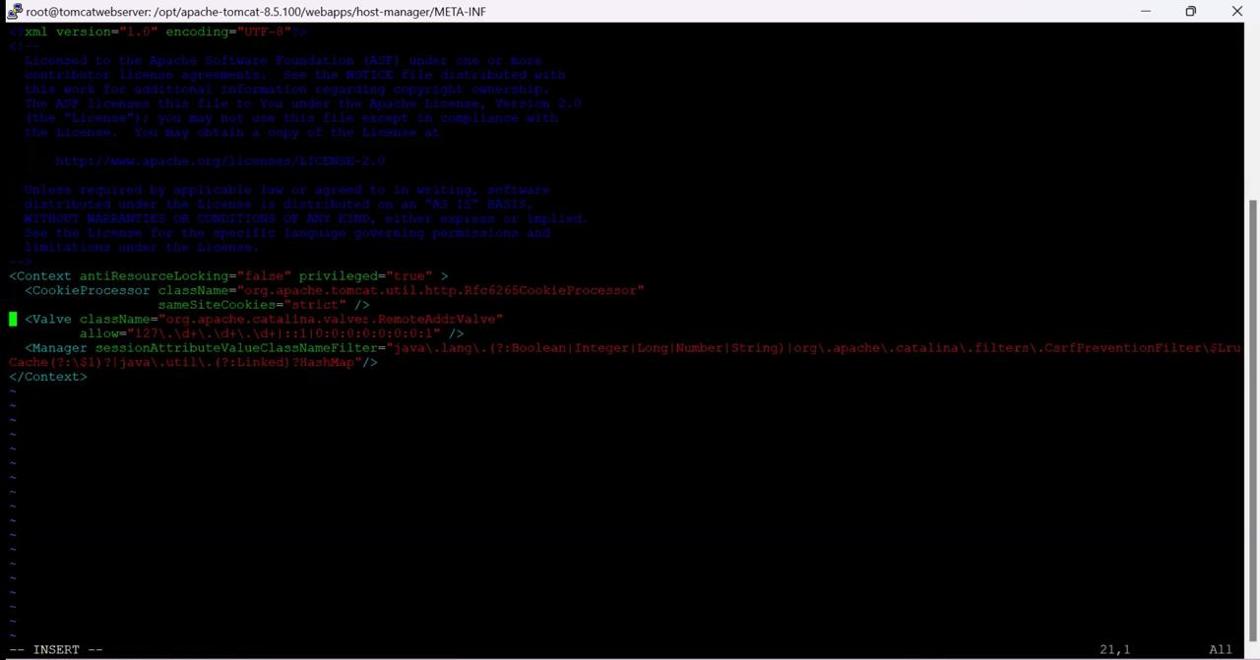vi context.xml

click ‘ i’ to get insert mode.

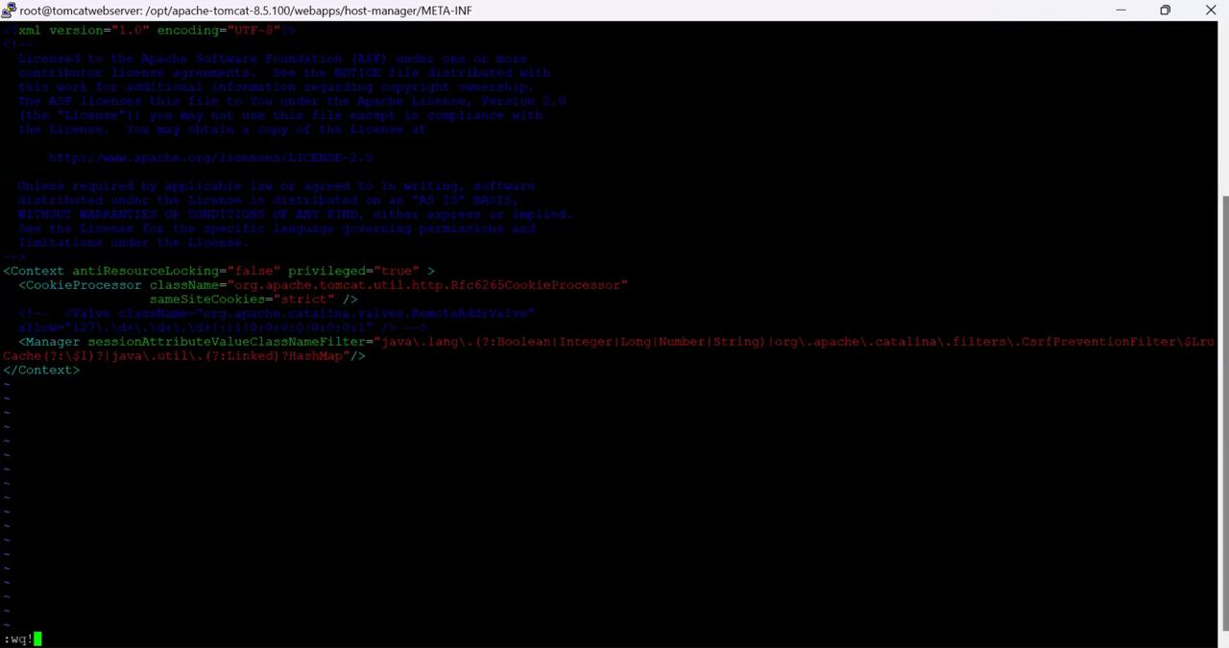

After adding code click esc+:+wq! to save and exit the changes.

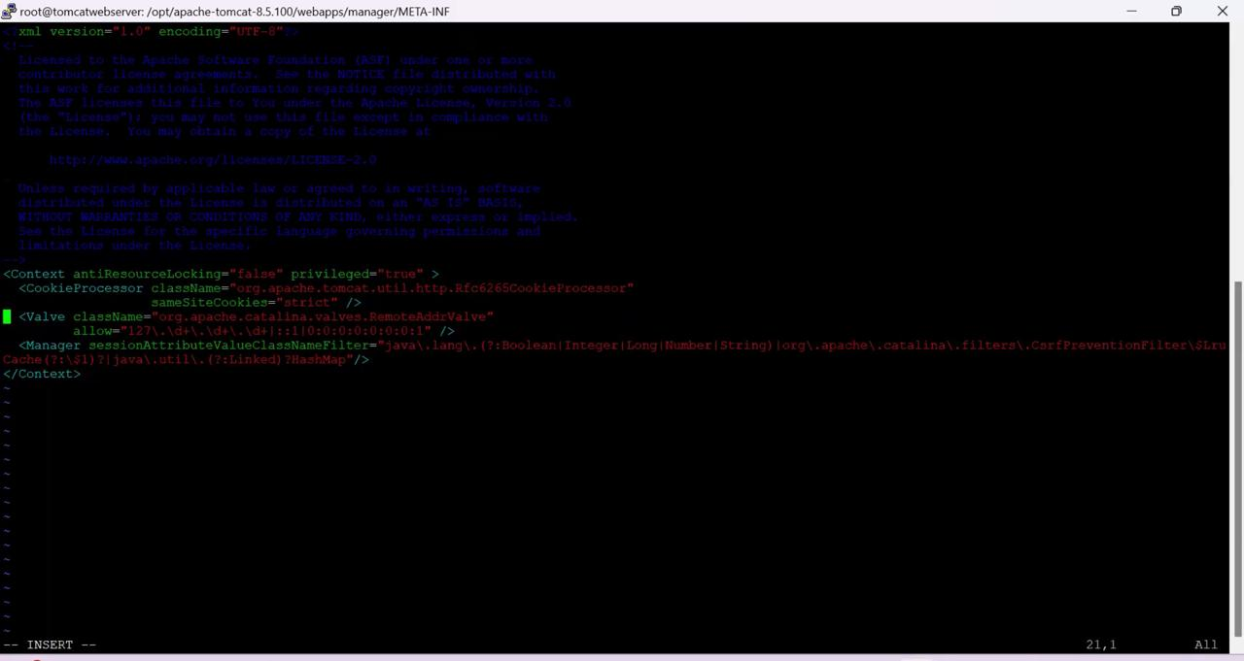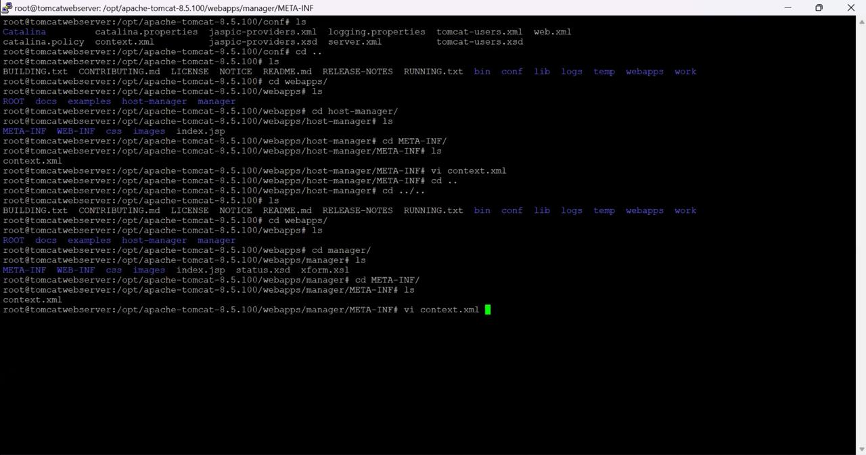

In another location also we have to do same change

* cd .. -> Go to webapps
* cd manager/META-INF
* vi context.xml

Press ‘ i’ to get insert mode

Add the comments to the code,

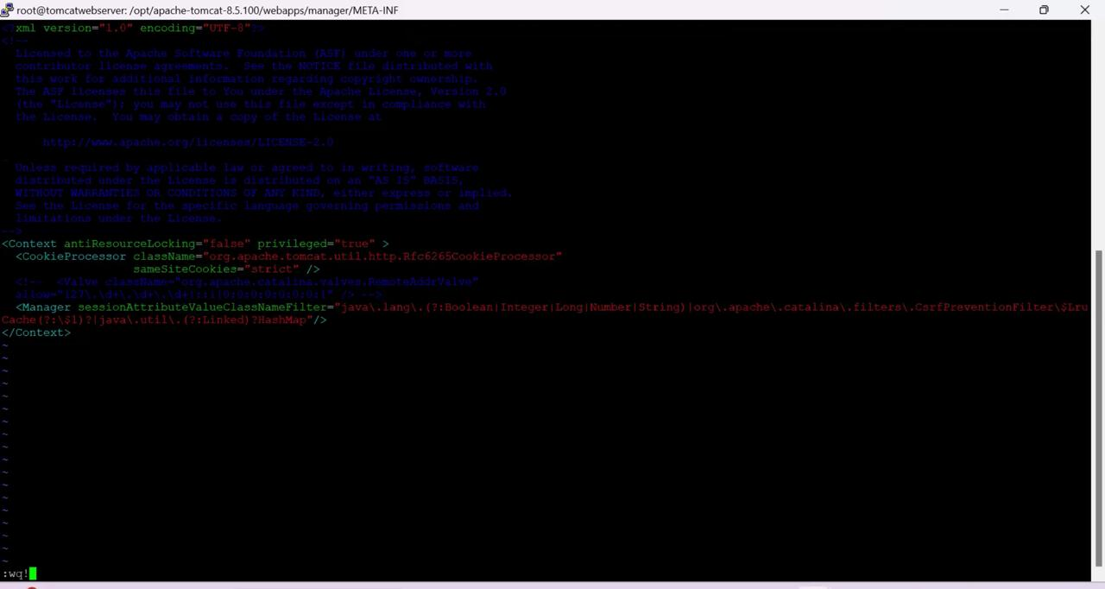

Press esc+ : + wq! to save and exit

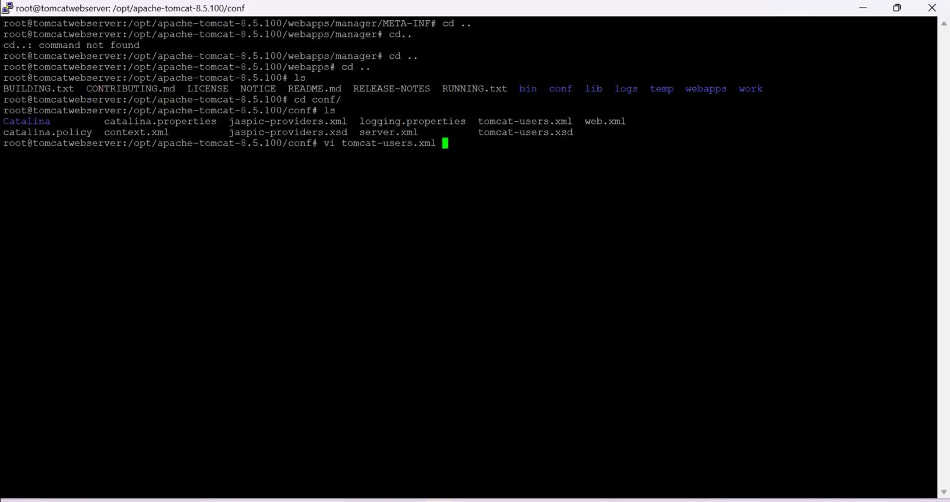

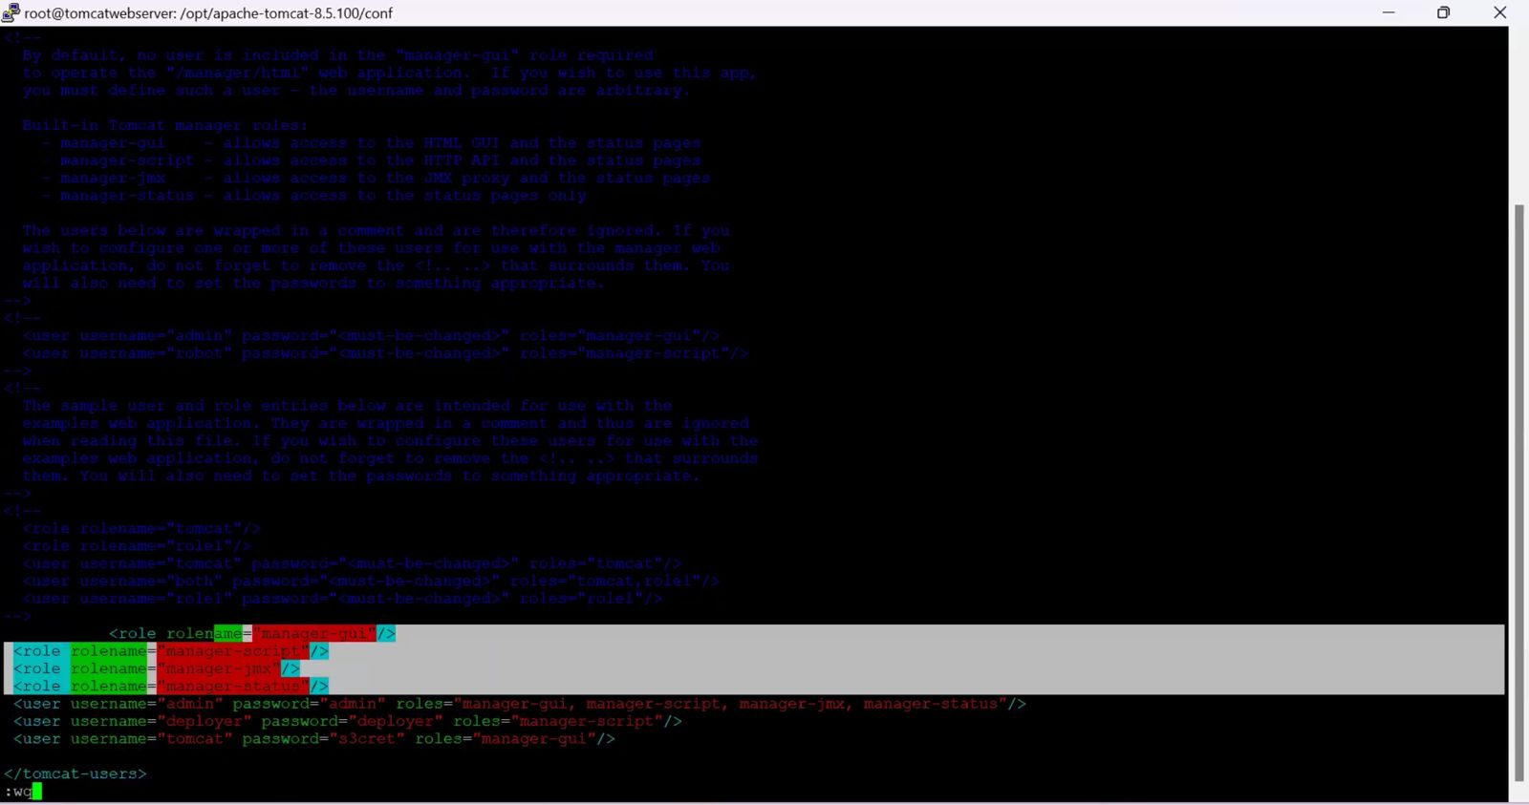Go to the conf and we need to add roles in tomcat-users.xml

Add the extra roles code as follows:

<role rolename="manager-gui"/>

 <role rolename="manager-script"/>

 <role rolename="manager-jmx"/>

 <role rolename="manager-status"/>

 <user username="admin" password="admin" roles="manager-gui, manager-script, manager-jmx, manager-status"/>

 <user username="deployer" password="deployer" roles="manager-script"/>

 <user username="tomcat" password="s3cret" roles="manager-gui"/>

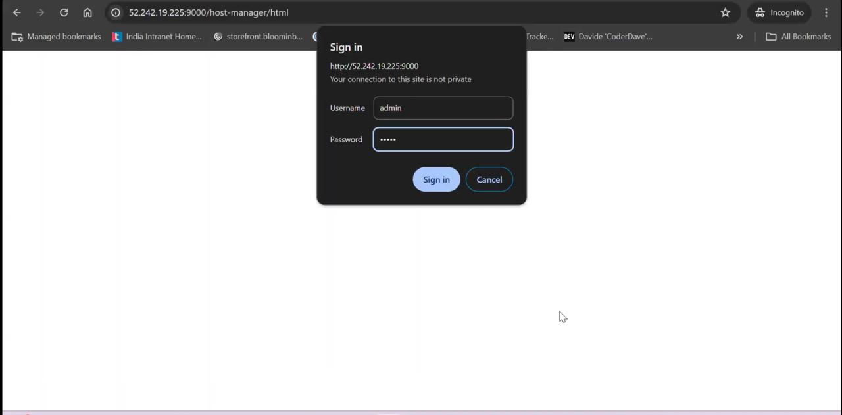

Enter username and password as admin and click on sign in

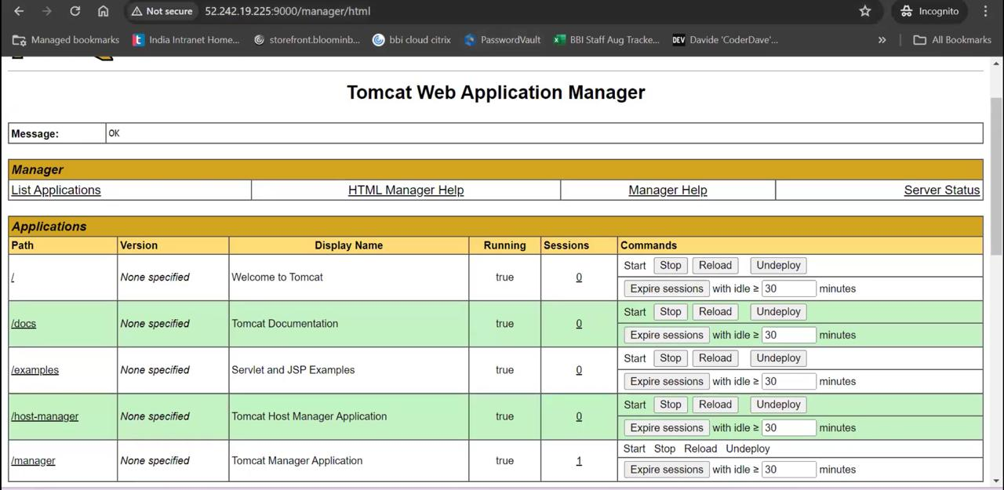

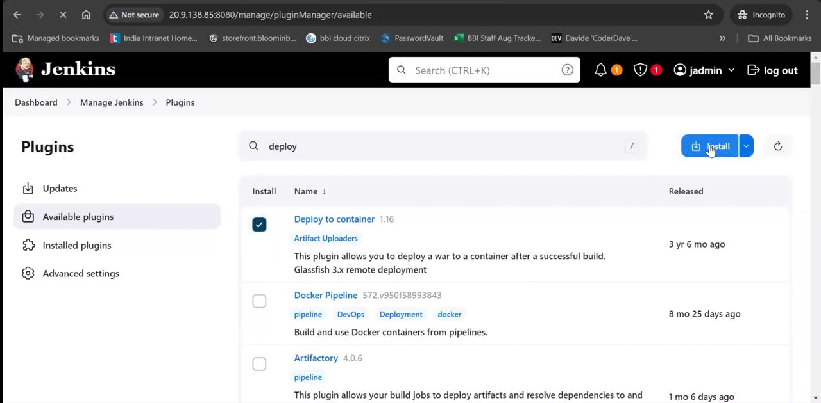

Install Deploy to container in Jenkins

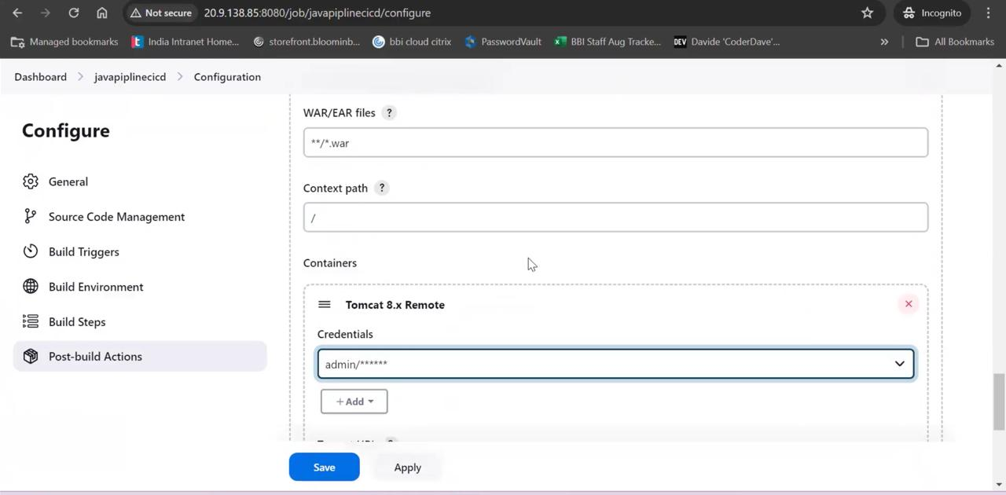

Go to configuration and select Post-build Actions

Add details Deploy to container as above shown figure.In details of container give your credentials and Tomcat url and click on apply and save

**Jenkins Build periodically:**

If you want to schedule your project build periodically then you should select the Build periodically option from the build triggers.

This field follows the syntax of cron (with minor differences). Specifically, each line consists of 5 fields separated by TAB or whitespace:

MINUTE HOUR DOM MONTH DOW

MINUTE Minutes within the hour (0–59)

HOUR The hour of the day (0–23)

DOM The day of the month (1–31)

MONTH The month (1–12)

DOW The day of the week (0–7) where 0 and 7 are Sunday.

*/2 * * * *  (Every 2 mins )

**Poll SCM:**

Poll SCM periodically polls the SCM to check whether changes were made (i.e. new commits) and builds the project if new commits were pushed since the last build.

*/2 * * * *  (Every 2 mins )

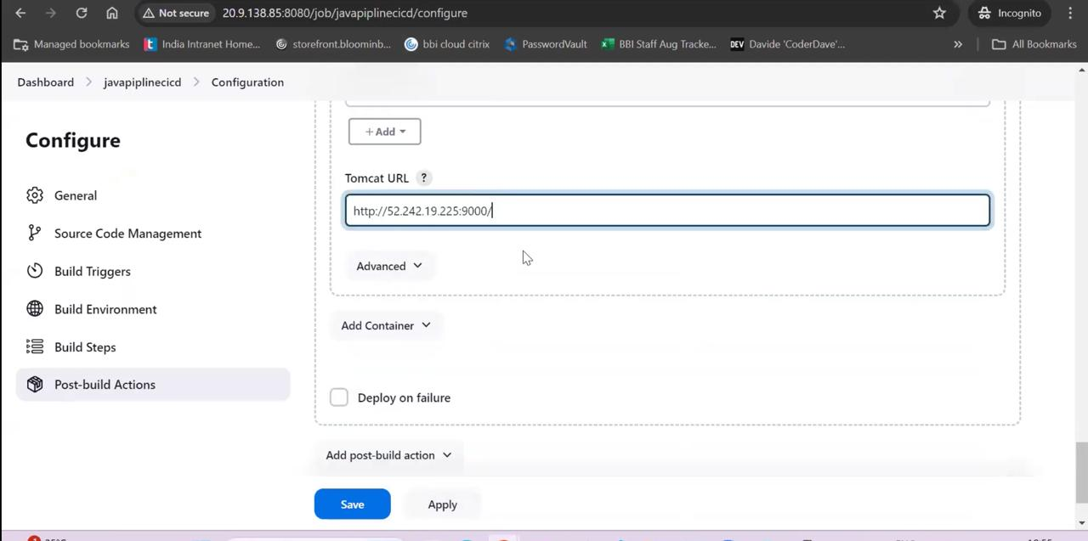

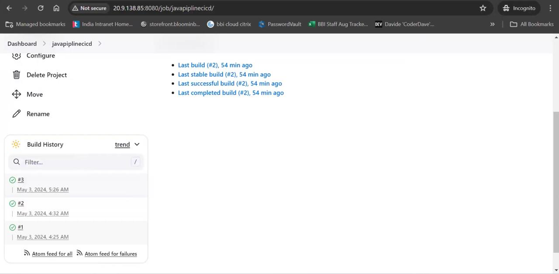

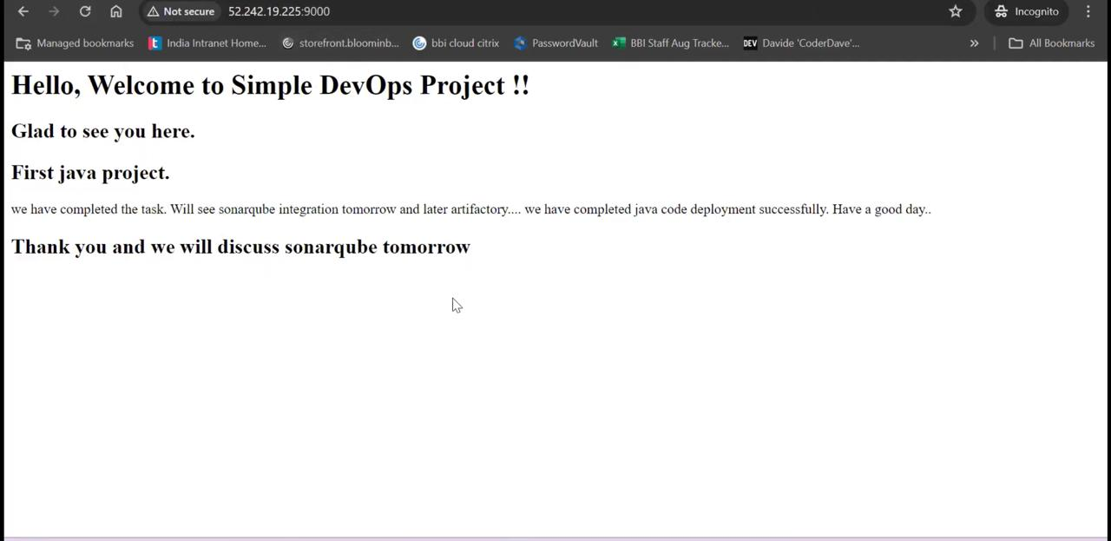Click on Build

Deployed successfully.